**Menofia University**

**Faculty of computer and information Graduation project 2020/2021**



CREDIT HOUR SYSTEM



**Supervisor**

***Dean / Arabi Keshk***

First of all we would like to thank **ALLAH** for granting us the power faith and blessings throughout this project.

We really would like to thank and appreciate our

## supervisor

**Dr. Arabi Keshk**

for her guiding, motivation, help and support at all time **.**

And finally we want to thank everyone helps us during the work in this Project.



**Team Members**

|  |  |  |
| --- | --- | --- |
| **Name** | **Dept.** | **Image** |
| **Mohamed Osama Mohamed Fahmy** | **CS** |  |
| **Mostafa Khaled Ebrahim** | **CS** |  |
| **Amr Magdy Mohamed Gomaa** | **CS** |  |
| **Amr Hasan Gad** | **CS** |  |
| **Walid Attia Abdelhamid Farag** | **IT** |  |
| **Ahmed Mohamed Ahmed Zaghlol** | **IT** |  |

# Chapter 1: Definitions

## Mobile Application

### What does Mobile Application Mean?

A mobile application (Mobile App), most commonly referred to as an app, is a type of application software designed to run on a mobile device, such as a smartphone or tablet computer. Mobile applications frequently serve to provide users with similar services to those accessed on PCs. Apps are generally small, individual software units with limited function. This use of software has been popularized by Apple Inc. and its App Store which sells thousands of applications for the iPhone, iPad and iPod Touch A mobile application also may be known as an app, Web app, online app, iPhone app or smartphone app.

### What do I need to download and use an app?

You need a smart phone, a tablet or another mobile device with internet access. Not all apps work on all mobile devices. Once you buy a device, you’re committed to using the operating system and the type of apps that go with it. The Android, Apple, Microsoft and BlackBerry mobile operating systems have app stores online where you can look for – and download and install – apps. Some online retailers also offer

app stores. You’ll have to use an app store that works with your device’s operating system. To set up an account, you may have to provide a credit card number, especially if you’re going to download an app that isn’t free.

Some apps are offered free to interest you in a company’s

other products. These apps are a form of advertising.

### What types of data can apps access?

When you sign up with an app store or download individual apps you may be asked for your permission to let them access information on your device. Some apps may be able to access your phone and email contacts, call logs, internet data, calendar data, data about the device’s location, the device’s unique IDs, and information about how you use the app itself. Some apps access only the data they need to function, but others access data that’s not related to the purpose of the app.

Data Plans and Wi-Fi: Two ways to access the internet from your phone:

**\*** You can access the internet using a data plan tied to your phone service, or through a Wi-Fi hotspot. Phone companies generally charge a monthly fee for a data plan that can connect you to the internet .

**\*** Wi-Fi connections usually are faster, but you have to be in range of a hotspot to use one. Most public Wi-Fi hotspots

– like those in coffee shops, airports, and hotels – don’t encrypt the information you send over the internet and are not secure.

Learn more about protecting your personal information on

public Wi-Fi networks at OnGuardOnline.gov/hotspots.

To set up a home Wi-Fi network, you’ll need to pay for internet access and a wireless router.

### Top 6 programming languages for mobile Development?

The language you choose for mobile development can be the difference between great success and tremendous frustration. There are options -- but only if you know which path you're on. Mobile devices are the fastest growing enterprise platforms in IT.

Enterprise IT shops and software publishers alike are moving every possible application to run on tablets, smartphones, and even smart watches. Behind that set of decisions, though, is a huge question: How do you make it happen?

There are two broad paths that can be taken. One path has the Web browser as its destination. The idea is simple: Write once for a Web browser and you don't have to develop a separate application for each platform. Of course, developers know that reality isn't nearly as simple as the idea, but programmers can still write versions of an application for many different platforms using a single language and many pieces of reusable code.

The question then becomes which single language to use -- and how to make the various pieces of the Web app puzzle come together.

The other path arrives at a dedicated app for each mobile

device. There are obvious costs associated with developing a separate app for each platform, but there are advantages, as well. One of the most important is that performance of a dedicated app will almost certainly be better than the performance of an app that has to run through a browser for everything that happens.

### HTML5

If you want to build a Web-fronted app for mobile devices, the one near certainty is HTML5. . The eventual standard will make various data types simple to insert, rationalize input parameters, level the browser playing field, account for different screen sizes, and probably freshen your breath and give you lush, manageable hair. Eventually.

The problem is that HTML5 is still a proposed standard that is currently supported in a lot of different ways by a lot of different browsers. It’s certainly possible to write HTML5 Web pages now, and many people are doing just that. They just have to know that there might be slight tweaks in the language in months to come and more substantial changes in the way browsers handle HTML5.

From a cost and efficiency standpoint HTML5 has the advantage of building on the current version of HTML so the learning curve is much shallower than that for a completely new language. If you can cope with a bit of uncertainty and want to walk the browser-based path, HTML5 is an obvious choice for a primary language.

### JAVA

Java is an object oriented programming language developed. At Sun Microsystems It is now owned, along with the rest of Sun Microsystems, by Oracle. It is, by most accounts, one of the most frequently used programming languages around, and so the skills are available in many individuals offering their services to enterprises. That's very good news. More good news comes from a performance standpoint. Java is a compiled language that can be run in two different ways: either in a browser window or in a virtual machine that doesn't require a browser. That flexibility tends to mean a lot when it comes to re-using code and updating software. If you're looking at Android as your primary plat form you’re almost certainly going to look at Java. If iOS is your main target, you probably won't be doing Java-first development. And if you want to develop a common code base that runs across many different platforms, then Java should certainly be on your list of finalists.

I mentioned that we were starting with Java. A quick note on JavaScript: It is, as the name implies, a scripting language for Web browser apps. It can be useful for adding features to a Web page, but isn't, by itself, the solution you're looking for when it comes to mobile app development. Keep it in mind, though, if you're walking down the HTML5 path.

### 1.1.4.3 C++

When you need to get down and dirty for apps on platforms like Android and Windows, then C++ can be the answer to

your object-oriented dreams. At this point, C++ has been used to develop apps for virtually every purpose on pretty much every platform that exists. Programming skills are widely available and the language is a well-known quantity. It's not trendy or ultramodern -- it's been around much longer than smartphones -- but for low level programming it's still the go- to language on platforms that aren't fruit themed.

### Objective C

While most of the world was developing software using C++, Apple went with Objective C as its primary programming language. Like C++, Objective C is a C-language superset. It does many of the same things for C that C++ does, though it has a number of functions that specifically deal with graphics, I/O, and display functions. Objective-C is part of the Apple development framework and is fully integrated into all iOS and MacOS frameworks. It is in the process, though, of being replaced in the Apple ecosystem -- by Swift.

### Swift

Apple's latest APIs are Cocoa and Cocoa Touch. The language to write code for them is Swift. According to Apple, Swift is written to work along with Objective-C, though it's obvious that the company intends for many developers to turn to Swift for complete programming. Among other things, Swift has been designed to eliminate the possibility for many of the

security vulnerabilities possible with Objective-C. If you're now beginning the process of writing iOS apps, then Swift should be your starting point. If you've been developing apps for iOS, then it’s time to start training your developers on Swift.

As an additional justification for Swift, at WWDC 2015 Apple announced that Swift will be going open source this fall.

That's bound to increase the number of people willing to work with Swift and increase the number of projects for which Swift becomes the primary development language.

### C#

C# plays the role in the Microsoft universe that Objective-C plays in the apple cosmos: It's an expansion of C that directly addresses many of the unique features of the environment. The Windows Mobile platform hasn't been the market- changer that many had predicted (and hoped), but there's no denying the gravitational pull of Windows across multiple platforms. If your fleet of mobile devices includes Windows then your suite of development languages should include C#.

### Which Language to use?

So which language is the "best" for mobile development? As with so many other topics in the software development world, the best answer is "it depends." If you want to do native development on iOS, your hand is forced. If you want to build

an app with a browser front-end, have rich media as part of the experience, and would like to have your app relatively future- proofed, then there's only one real choice. For everything else, you'll have to look at the experience in your staff, the needs of your users, and the budget for the project.

People tend to be invested in languages and systems. Which would you choose? Where have you made your mobile development investment? I'd love to hear what you have to say.

In our case we want to build android-based application so We will use flutter for developing our credit system mobile application.

### The Importance of User Experience for Mobile APPs?

Therefore, there is a need to adopt a user-centered approach to mobile application development that gives emphasis to the needs of target users. Improved UX translates into several key benefits for the companies that provide it, and here are some of them:

### Loyal User Base

Everyone has the experience of using an app with lots of bugs and errors, complexities, frustrating interactions and unexpected behaviors. The truth is that, a poorly designed application reduces customer loyalty. Users won’t have a high tolerance for unstable applications and nothing can turn them away faster than a bad first impression. You may not be

able to foster a lasting relationship with users. On the contrary, a good user experience can create the kind of loyalty that keeps people coming back for more, increasing engagement. Giving users a reason to return by being engaging and useful is one of the ways to enhance UX and encourage member loyalty. This leaves a positive first impression on the user and gives them a sense of value for having downloaded your app**.**

### Reduce Support Costs

A well-designed app can save you money and time. Consumers regularly struggle with simple issues that solutions can easily be found on a well designed app. Mobile applications give customers a way to not only find solutions but to connect with your business 24/7, irrespective of where they are. They can offer direct personal calls with sales people, access to a help desk, live chat and even provide on- going support to customers. You can save a lot of money as you do not need to hire as many help desk staff. Also, users

won’t waste as much time asking for help. The app can provide all the information a customer needs on your company and products instantly, and in turn, will result in a higher level of engagement with your brand.

### Increased Customer Satisfaction

Customer satisfaction is one of the keys to running a successful business. Success in any industry is often measured

by the number of satisfied customers. The better experience you provide for your clients, the more satisfied they will be – and the opposite is true. The worse experience you create for your customers, the more frustrated they will become with your offering. They will rarely recommend your product to their friends and relatives. The same applies to mobile applications.

If people do not like your app or do not use it, chances are users’ expectations aren’t being met or not enough value is being offered. So if you make an app that frustrates or annoys those, chances are your application will be deleted and get bad reviews.

The most common reason why users might abandon or delete an app is poor user experience. This includes heavy battery usage, slow responsiveness, too many ads and so forth. If an app can’t provide a positive first impression, it is probably going to frustrate users and it is likely going to be deleted.

### Increased Sales

A well-designed app will have increased traffic, transactions, and conversations. These apps will attract and keep more clients who will buy more products and leave positive feedback. Happy customers often spread the word to their friends and families. Users won’t share your app if it fails to meet their expectations. They also review your application online, which plays an important role in convincing other potential users to download the application. Also, the reviews reflect the current user satisfaction with the application.

Remember online reviews is a trusted sources of information, and building trust with users is a key component in ensuring that more people download and use the app.

Providing a great experience helps promote positive word of mouth, thereby increasing sales. Again, it leads to increased customer satisfaction and loyalty, and thus repeat business. User-centered designed also minimizes the number of bug fixes and maintenance needs that often surfaces after launching an app. Identifying glitches in advance can save thousands if not millions of dollars on app updates in the future.

### It Gives You an Edge Over the Competition

It is nearly impossible to stand out in a crowd of well over a million As of July 2015. Android users, for example, were able to choose more from than 1.6 million applications. Apple Store is the second largest app store after Play Store with over 1.5 million apps. It is important that your app stands out from the rest. However, making your product stand out in a saturated market is not as easy as you think.

While there are a lot of tricky gimmicks that you can try to make your app noticeable, you need to involve the user from the beginning in order to succeed. You have to make sure your item is user-friendly – before anything else. Users are attracted to apps that can provide them with what they really want.

### Final Thoughts

A well-thought-through mobile solution needs to conform to your overall digital strategy, offering a seamless and unmatched user experience. This means that the functionality and content that are delivered on your app must be in line with what your target audience actually wants. Regardless of the function or purpose of your app, the end product must provide a superior quality user experience. If you are unable to provide a quality mobile experience, you could be doing more harm than good to your reputation.

## Web Application

* + 1. **What does Web Application (Web App) mean?**

In computing, a web application or web app is a client–server software application in which the client (or user interface) runs in a web browser. Common web applications include webmail, online retail sales, online auctions, wikis, instant messaging services and many other functions.

The general distinction between a dynamic web page of any kind and "web application" is unclear. Web sites most likely to be referred to as "web applications" are those which have similar functionality to a desktop software application, or to a mobile app. HTML5 introduced explicit language support for

making applications that are loaded as web pages, but can store data locally and continue to function while offline.

Single-page applications are more application-like because they reject the more typical web paradigm of moving between distinct pages with different URLs. Single-page frameworks like Sencha Touch and AngularJS might be used to speed development of such a web app for a mobile platform.

## What do I need to download and use web app?

You need a Desktop, a Lap top or another mobile device with internet access. Not all apps work on all devices. Once you buy a device, you’re committed to using the operating system and the type of apps that go with it. The Apple, Microsoft, Unix Based operating systems have app stores online where you can look for – and download and install – apps. Some online

retailers also offer app stores. You’ll have to use an app store that works with your device’s operating system. To set up an account, you may have to provide a credit card number,

especially if you’re going to download an app that isn’t free. Some apps are offered free to interest you in a company’s other products. These apps are a form of advertising.

|  |  |  |  |  |
| --- | --- | --- | --- | --- |
| P a g e | 16  **1.2.3 What types of data can apps access?**  When creating tables in Access web apps, you need to select a data type for each column of data. This table shows the data types available for Access web apps and what kind of data they’re suitable for: | | | | |
|  | **Data type** | **Subtype property setting** | **Description** | **Corresponding SQL Server data type** |
| AutoNumber | n/a | Unique value generated by Access for each new record. | Int |
| Short Text | n/a | Alphanumeric data, 1 to 4000 characters (default character limit is 255). | nvarchar with length from 1 to 4000 |
| Long Text | n/a | Alphanumeric data, up to 2^30-1 bytes. | Nvarchar (max) |
| Number | Whole Number (no decimal places) | Numeric data. | Int |
| Number | Floating-point number (variable decimal places) | Numeric data. | Double |
| Number | Fixed-point number (6  decimal places) | Numeric data. | decimal(28,6) |
| Date/Time | Date | Dates. | Date |
| Date/Time | Time | Times. | time (3) |
| Date/Time | Date with Time | Dates and times. | datetime2(3) |
| Currency | n/a | Monetary data. | decimal (28,6) |
| Yes/No | n/a | Boolean (yes/no) data. | bit (default is false) |
| Hyperlink | n/a | A link address to a document or file on the Internet or on an intranet | nvarchar(max) |
|  | | | | |

|  |  |  |  |  |
| --- | --- | --- | --- | --- |
| P a g e | 17 | | | | |
|  | Image | n/a | Picture data. | Binary Image data varbinary(max), 2^31-1  bytes |
| Calculated | n/a | Results of an expression you create using data from one or more fields in the table. | Depends on the results of the expression. |
| **1.2.4 Top 6 programming languages for Web Development?**  he universe of programming languages is wide and knowing all or learning each one of them is neither practical nor possible. If you are a developer who is interested in learning the most useful and popular ones, then you must first know which ones of the thousands of languages to learn. Thankfully, there are certain websites and platforms that create lists of the top languages, according to their popularity. The list of the top 15 programming languages of this year are given below, and it is clear that JavaScript is the most popular followed closely by Java, Python, and others. There are two broad paths that can be taken. One path has the Web browser as its destination. The idea is simple: Write once for a Web browser and you don't have to develop a separate application for each platform. Of course, developers know that reality isn't nearly as simple as the idea, but programmers can still write versions of an application for many different platforms using a single language and many pieces of reusable code.  The question then becomes which single language to use -- and how to make the various pieces of the Web app puzzle come together The other path arrives at a dedicated app for each mobile device. There are obvious costs associated with developing a separate app for each platform, but there are advantages, as well One of the most important is that performance of a dedicated app will almost certainly be better | | | | |

than the performance of an app that has to run through a browser for everything that happens.

### JavaScript

JavaScript is one of the most popular and dynamic programming languages used for creating and developing websites. This language is capable of achieving several things including controlling the browser, editing content on a document that has been displayed, allowing client-side scripts to communicate with users and also asynchronous communication. It was developed by Netscape and borrows a lot of its syntax from C language. JavaScript is used very widely and effectively in creating desktop applications as well as for developing games.

One of the best things about JavaScript for you as a developer or a website owner is that this is one of the few programming languages that are accepted and supported by all the major browsers without the need of any compilers or plug-ins. It can also be worked with on platforms that are not web-based, for example-desktop widgets and PDF docs. This is a multiparadigm language which means that it has a combination of features. Also, JavaScript supports functional and object-oriented programming styles.

The features of a language define the way it will work, the way it responds, how easy is its code and what it can achieve. The following are some of the main features of JavaScript programming language for your reference:

**\* Structured –** JavaScript is a highly structured language with a proper and planned syntax that has been derived from C. This language too has a function scoping by it lacks block scoping, unlike C. It too differentiates between statements and expressions, just like the fundamental C web programming platform.

**\*Dynamic –** The types in JavaScript are not related with variables but with values. This is a dynamic programming language that enables you to test the type of an object in many different ways. Also, this programming language is object-oriented where all the objects are associative arrays.

**\*Functional –** All functions in JavaScript are objects and are all first class. They are associated with their own functions as well as characteristics. For example, a function within a function is called a nested function whereas this language also supports anonymous function

### JAVA

Java is yet another highly popular and widely used language that you can consider for web development. This language is an object-oriented, class based and concurrent language that was developed by Sun Microsystems in the 1990s. Since then, the language continues to be the most in-demand language that also acts as a standard platform for enterprises and several mobile and games developers across the world. The app has been designed in such a way that it works across several types of platforms. This means that if a program is written on Mac Operating system then it can also run on Windows based operating systems .

Java, when it was designed originally, was developed for interactive television, but the developers realized that this language and technology was way too forward for this industry. It was only later that it was incorporated into the use it serves today .

Every language is created with a certain mission, goal or objective in mind. The following are the 5 major principles or goals that were kept in mind during the creation of this language:

\***It** must be a secure and robust programming language.

* **It** must be an object-oriented, simple language which becomes familiar soon.

**\*It** must be capable of being implemented and executed with high performance

* **It** must be threaded, dynamic and interpreted.
* **It** must be portable and architecture-neutral.

### Python

Python is a highly used and all-purpose programming language which is dynamic in nature. Being dynamic in nature means that you as a developer can write and run the code without the need of a compiler. The design of the language is such that it supports code readability which means that its syntax is such that only a few lines of codes are needed to express a point or a concept. This concept of code readability is also possible in the case of Java and C++, etc. This is a high-

level or advanced language that is considered easy for beginners to understand and learn.

Some of the apps that are powered by Python are Rdio, Instagram, and Pinterest. Besides this, some other web platforms that are supported by Python are Django, Google, NASA, and Yahoo, etc.

. Some of the other features of this language include automatic memory management, large library, dynamic type system and support of many paradigms.

Python works on a core philosophy and follows its main principles in all seriousness. The language was designed with the aim of making it highly extensible. This means that the language can easily be incorporated or embedded in existing applications. The goal of the developers of this language was to make it fun to use one. The developers worked on the language in such a way that it could reduce upon premature optimization. Here’s a look at some of the principles that have been summarized for you:

Readability is important.

Complex is better than complicated. Beautiful is better than ugly .

Simple is better than complex. Explicit is better than implicit**.**

### C Language

C is another general-purpose and imperative programming language which was developed way back in the 70s and is similar to C++ language. This language is known to be the

most widely used programming platform that offers building elements for other languages like C++, Python, Java and others. These languages borrow features either directly or indirectly from it, and some of these include control structures, overall syntax, and standard libraries. This is the reason why if you want to learn programming, it is advisable that you learn C and C++ first and then move onto the others after strengthening your foundation. Some of the features that this language supports include static type system, lexical variable scope, recursion and structured programming.

The following are some of the points which shall help you understand the overall design of C language:

**\*** C is a procedural or imperative language .

* The language was designed in such a way that can be easily compiled by making use of a simple compiler
* The language was designed to offer a low-level access to memory
* It was designed in a way that it should need minimum possible runtime support and encourages cross-platform programming

### PHP

The term ‘PHP’ is used to define PHP Hypertext Processor language that is a free server-side scripting language that has been designed for not just web development but also as a general-purpose programming platform. This is a widely used language that was created in the year 2004 and now powers

over 200 million websites worldwide. Some popular examples of websites powered by this platform include Facebook, WordPress, and Digg.com.

PHP is an interpreted script language which means that it is usually processed by an interpreter. For this reason, the language is most suitable for server-side programming that have server tasks being repeatedly performed when the website development process is on.

The following are some more points that shall help you understand the language better:

* **PHP** is an open source language and fast prototyping language
* **This** language is compatible with UNIX based OS as well as Windows OS
* **Some** industries where PHP is mostly used include startup businesses, advertising apps, and small software organizations as well as media agencies
* **The** language can be embedded in HTML directly

### Ruby

Developed in the year 1993, Ruby is a dynamic programming language that is used for the creation or programming of mobile apps and websites. The language successfully balances imperative programming with functional programming and is a highly scalable language. This open source platform is not

only simple to understand but also easy to write. But if you are a developer who wants to learn Ruby, then you will also have to equip yourself with the knowledge of Ruby on Rails or Rails which is another framework which can help you make it interesting to deal with Ruby. For those who are interested in creating small business software and for those who are into the field of creative designing, Ruby is the perfect programming language.

During its development, the idea was to come up with a language that was more productive in terms of programming and has a concise and simple code. Ruby is mostly used in the web servers where there is a lot of web traffic. Some examples of platforms that make use of this programming language include Hulu, Twitter, and Scribd, etc.

### Which Language to use?

So which language is the "best" for Web development? The universe of programming languages is wide and knowing all or learning each one of them is neither practical nor possible. If you are a developer who is interested in learning the most useful and popular ones, then you must first know which ones of the thousands of languages to learn.

In our case we will use PHP as A Web development programming Language as PHP:

**\*PHP** is an open source language and fast prototyping language.

* **This** language is compatible with UNIX based OS

as well as Windows OS.

* **Some** industries where PHP is mostly used include startup businesses, advertising apps,

and small software organizations as well as media agencies.

**\*The** language can be embedded in HTML directly.

### The Importance of User Experience for Web Apps?

To create an excellent website that best suits your business’ needs, you’ll need to create a web page that’s aesthetically pleasing, informative, and easy to navigate. If your web page is missing one or more of these components, the chances of you attracting clientele and boosting your conversion rates are severely inhibited. This is why it’s essential to consider user experience, or UX, when creating a website that showcases your goods and services.

Think of UX as the ergonomics of your personal website. When you design a webpage that’s centered on user experience, you create a space that’s easy for the reader to access, understand, and navigate. This, in turn, sets your website apart from

competitors who aren’t as concerned about UX, thus increasing

your traffic and customer base.

There are many factors that go into creating an optimal user experience. They involve combining form and function to carry out a final goal. Breaking them down into steps will help give more insight into creating the optimal user experience.

### Consider the industry

the website will be applied to and the target audience that may become users of the site. How are they expecting the site to look and function?

### Think of the goal

Think of the goal of the website and what action you would like the users to complete. Is the best possible outcome a potential lead contacting your company personally? Is it purchasing a product?

### Utilize the idea of flow

When beginning to design the site, it is important to utilize the idea of flow. Creating this flow involves the visual design, content and navigation of the site. Is navigating the site cohesive yet stimulating, easy to understand, yet entertaining to peruse and keeps the user’s attention? In creating the main pages and sub-pages, it is important to make sure that the visual flow, as well as the flow of the content, are seamless to make the path to the final goal seamless. This seamlessness can also create a feeling of flow within the user. Flow, as an action, is defined as the state in which one becomes fully and positively immersed in an activity to the point they lose conception of time. Some athletes would describe flow as “the sweet spot.” When users feel flow, they are fully immersed in the exploration of a new and relevant website and are more likely to follow the flow and fulfill the ultimate goal.

### Design with a human touch in mind

During the website design process, it is also important to design with a human touch in mind. A user will respond more positively if the website seems as though it was designed for them and what they are seeking when visiting the website.

Being as straight forward as possible with both design and content can achieve this, but adding some warm and/or humorous yet professional undertones can instigate the flow you want to initiate.

If the user is receiving all the information they are seeking in a stimulating and efficient way, but also feel as though some thought was put into the presentation, as though they are interacting with another human in an entertaining way, they build trust with the website and, ultimately, the company and individuals that work for the company. Initial interaction with the user once the user has made contact is almost always more positive than if the site had been confusing and less welcoming.

While creating a website design that successfully includes all of these ideas might sound like it’s easier said than done, if incorporated into the initial brainstorming process and carried out throughout the design, it will still come through the design and make a noticeable difference in the final result.

# Chapter 2 : Introduction

* 1. **Title of project :**

**credit hour system**

## Project Description

**credit system:**

Is an android application and a website that help student to register courses, access materials, follow course grades, obtain a statement of success, deal with the college’s administration, review the schedule of lectures and studies, assist doctors in raising materials to make it easier for students to obtain them, and assist the auxiliary body to communicate directly with students to follow up on all academic advising work and assist the college administration in setting appointments. Registration and closure and management of how to register Follow-up actions of withdrawal and excuses.

## Our application will have also:

**FAQ Module:** This module will contain the frequent answered Questions :

* Allows student to read FAQ for

different fields.

* Allows student to ask any new questions.

**Social media Module:** Is the module that will allow student to communicate with each other as:

* Provide chat with other students.
* Posting new posts on student profile
* Creating Team with other student to complete some projects
* Allows student to build his portfolio and cv

## Motivation

Students in faculty of computer and information systems face a problem when they want to learn information about programming field such (Android, Java, web etc.) the important questions which students want an answer to them are “How can I start learning this Field?” And, “how can I work in this field as a professional developer?”.

## Languages to be used

* + 1. **Web Application**

HTML CSS



Javascript



React JS Spring

## Mobile Application (Android)

dart language. flutter platform.



## Future of our Project

Our project will be keep in touch with latest techniques and technologies .

It will be scalable .

make online learning easier .

# 3



Chapter 3: Modeling the Requirements



**3.1** Modules

### All Courses

Is The module which contains all available course in different programing fields such Android courses, IOS courses, HTML courses etc.

1. It helps Student to view all available courses in different programing fields
2. It helps student to find a specific course in any of available programing field .

### Start Career

Is the module which be the start point for student who want to learn new programing field and then working with it.

1. it allows the student to perform a test in the field he want to learn to dedicate the experience level of student in this field .
2. Provide student with a set of courses according the result of test he has passed .
3. . When the student completed his list of courses we will assign to him task of real projects in his field .
4. Eventually if when student finished tasks assigned to him perfectly he then can work as a professional programmer in our company.

### Social Media

Is the module that will allow students to communicate with each other .

* + - 1. Provide chat with other students .
      2. Posting new posts on student profile.
      3. Creating Team with other student to complete some projects.
      4. Allows student to build his portfolio and cv.

### Student

The user of credit system , He can use modules of: 1- All courses.

* 1. Start Career
  2. Social Media
  3. FAQ

### Administration

The module which allows company administrators to control the system, allows administrators of SWORK System to control modules of :

1- All courses . 2- Start Career.

1. Social media .
2. Partners.
3. FAQ .

### Chat

The module which will allow student to know more information about our project and also about fields of programming which student want to learn **:**

1. Allows student Chat with our bot to know more information about anything in our application
2. Will help student who not know about programming fields to know about each field

### FAQ

The module which will contain frequent answered questions: 1- Allows student to read FAQ for different fields

2- Allows student to ask any new questions .



**3.2 User Requirements**

### Sign up

Allows new Students to fill registration form which contains information such First-name, Last-name, User-name, Mobile phone, Confirmation email address and Password to create new user account **.**

### Log in

Allows registered students to log in to their profile and access their home page, profile, courses, etc.

### Sign out

Allows Logged in user to sign out from his account **.**

### Search for course

Allows Logged in students to search for material in specific course **.**

### Show all course

Allows Logged in students to view all available course categorized by fields .

### Roll in course

Allows Logged in students to roll in course and start learning it**.**

### Perform Test

Allows Logged in students to perform a test in specific field he want to learn and then give to student a list of courses according to his test grades which will help student to be professional in the field he want to learn**.**

### Submit Task

Allows Logged in students to submit practical tasks assigned to them to be reviewed**.**

### Deactivate Account

Allows Logged in students to deactivate or delete his account in credit system .

### Show Profile posts

Allows Logged in students to show all his posts he posted in his profile in Social Media module **.**

### Show friends Post

Allows Logged in students to read his friends posts they posted in their profiles **.**

### Add Post

Allows Logged in students to add new post in his profile in Social Media Module **.**

### Update Post

Allows Logged in students to update old posts he posted in his profile **.**

### Delete Post

Allows Logged in students to delete old posts he posted in his profile

### Like Post

Allows Logged in students to Like posts other people post in credit system Social Media .

### Share Post

Allows Logged in students to share posts other people posted in their profiles **.**

### Chat

Allows Logged in students to chat

### View all FAQ

Allows Logged in student to view all FAQ questions categorized by fields**.**

### View Specific Field FAQ

Allows Logged in student to view all FAQ questions in specific field **.**

### Add new Specific FAQ

Allows Logged in student to add new FAQ in specific field **.**

### Update Specific FAQ

Allows Logged in student to update his FAQ in specific field

### Delete Specific FAQ

Allows Logged in student to delete his FAQ in specific field.

### Add answer of Specific FAQ

Allows Logged in student to add answer to another students’

FAQ in specific field **.**

### Update answer of Specific FAQ

Allows Logged in student to add update his answer to another

students’ FAQ in specific field

### Delete answer of Specific FAQ

Allows Logged in student to delete his answer to another

students’ FAQ in specific field

### System Requirement

* + 1. **Functional Requirement**

### create profile for each student and staff

* + - * **register for courses**

### allow staff to communicate with student

* + - * **student follow his grades**

### Non-Functional Requirement

* + - 1. **Security**

We will make a high level of security by adding encrypted method that encrypts the information of users so that we can save privacy of each user and protect data from hackers. And we will use MD5 hashing function which will be used in the sign in stage and Register to encrypt passwords **.**

### Performance

We will increase Performance by using advanced technology (intelligent search engines) that will increase speed of queries needed in functions of search, Delete and Show **.**

## UML Diagrams

It is referring to “Unified Modeling Language” that is a modeling

language in the field of software engineering, which is designed to

provide a standard way to visualize the design of a system.

UML has many types of diagrams which are divided into two categories structured UML diagrams and behavioral UML diagrams [Figure 2.2].

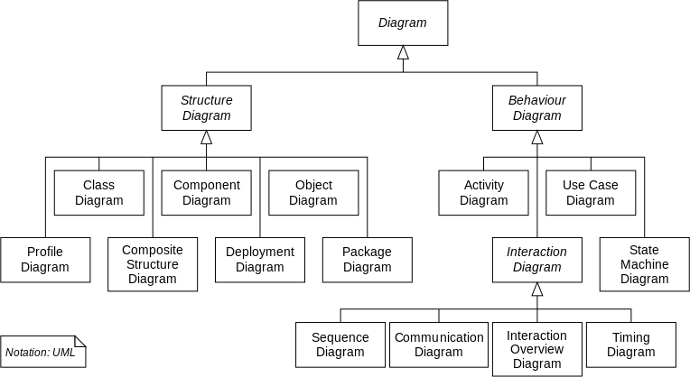



### Use case diagram

Use cases are used during analysis to represent the functionality of the system and focus on the behavior of the system from an external point of view.

A use case describes a function provided by the system that yields a visible result for an actor. An actor describes any entity that interacts with the system.

### student use case

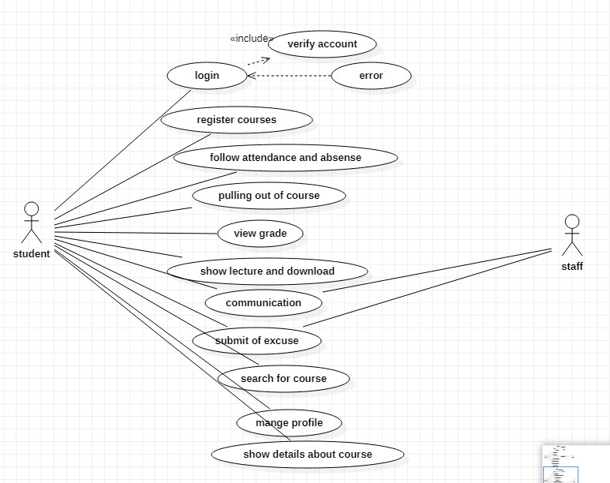

* + - * 1. **Login :**

First step to interact the student with the system by logging to the system used particular username and password**.**

### Register courses :

student can select what courses he want to register

in .

### Follow attendance and absence :

help student to know number of lectures and laps he attend **.**

### Pulling out of courses :

student can pull out of courses he was registered in .

### View grade :

student can view his marks on all courses and can print his grads .

### Show lecture and download :

each student can show his lecture and download it .

### Communication :

each student can communicate with doctors .

### Submit of excuse :

student can submit excuse of his absence.

### admin use case

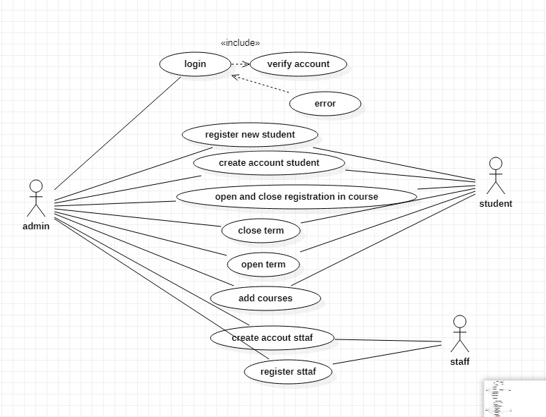

* + - * 1. **Login :**

First step to interact the student with the system by logging to the system used particular username and password.

### Register new student :

can accept new student every year throw the web application **.**

### Create account of student :

create account of new student who was accepted.

### Open and close registration in courses :

open the time of registration to make student register in courses and close it .

### Open and close terms :

put the time to start the term and time to finish it according to hours of courses.

### Add courses :

admin can add courses and delete it .

### create staff account :

create account for staff .

## staff use case

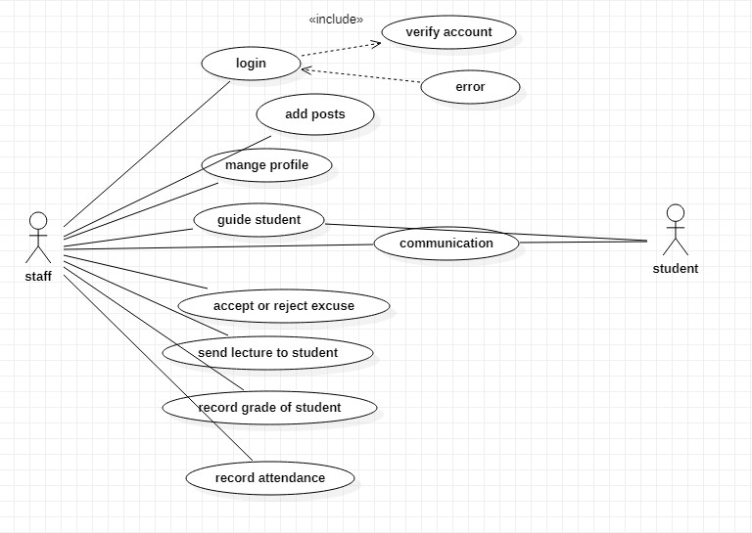

### Login :

First step to interact the student with the system by logging to the system used particular username and password**.**

### Add posts :

doctors can add posts on his profile to student.

### Manage profile :

staff can manage his profile .

### Guide student :

staff guide student in courses .

### Communication :

staff can communicate with student and each

other.

### Accept or reject excuse :

doctor can accept or reject the excuse of attendance and absent .

### Send lecture to student :

doctors send lecture to student to help them.

### Record grade :

doctor record grade of student and send it to

them.

### Record attendance :

doctor record attendance of student .

### sequence diagram

**This diagram describes the interaction between set of objects. It also shows how processes operate with one another and what their order is.**

### Sequence diagram is a behavioral UML diagram.

* + - 1. **student sequence diagram**

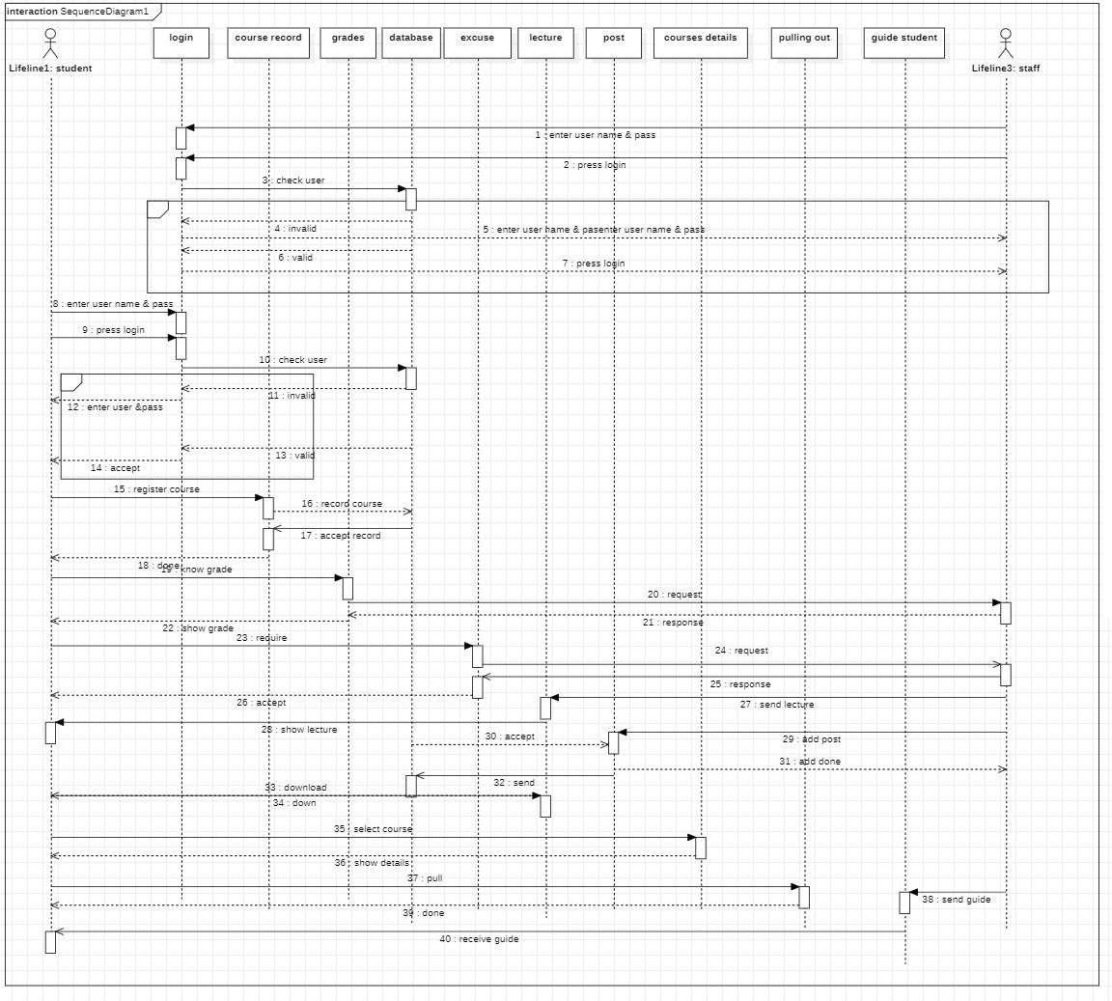

* + - 1. **admin sequence diagram**

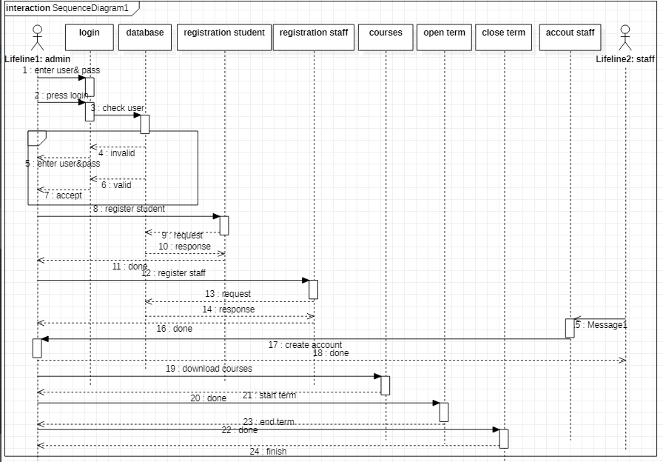

## class diagram

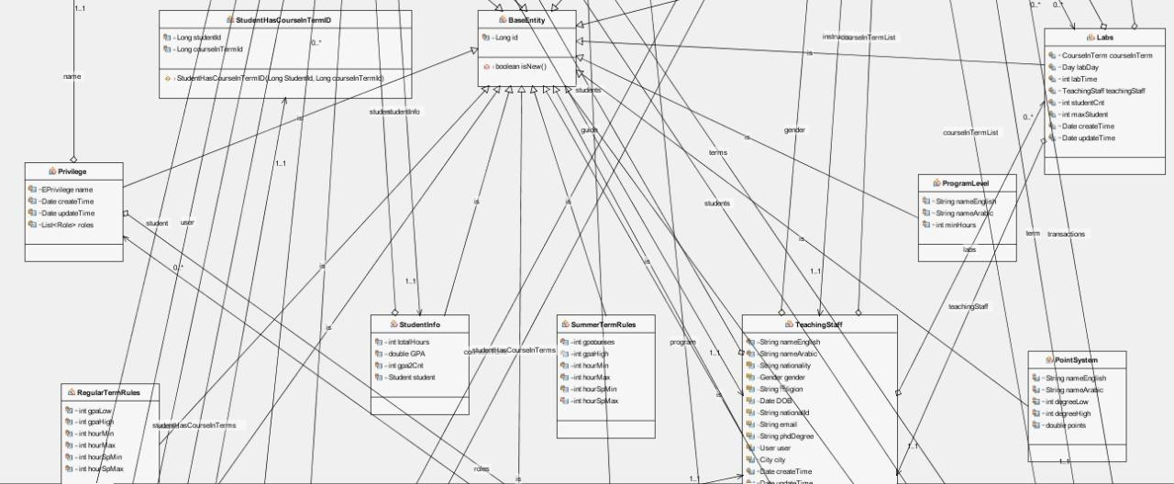

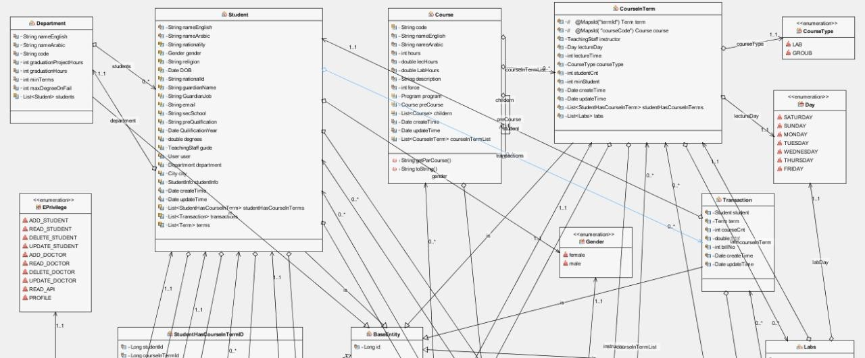

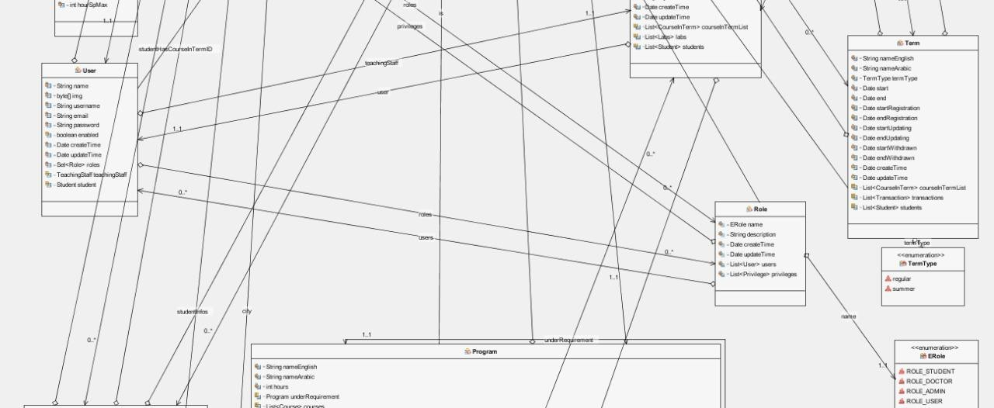

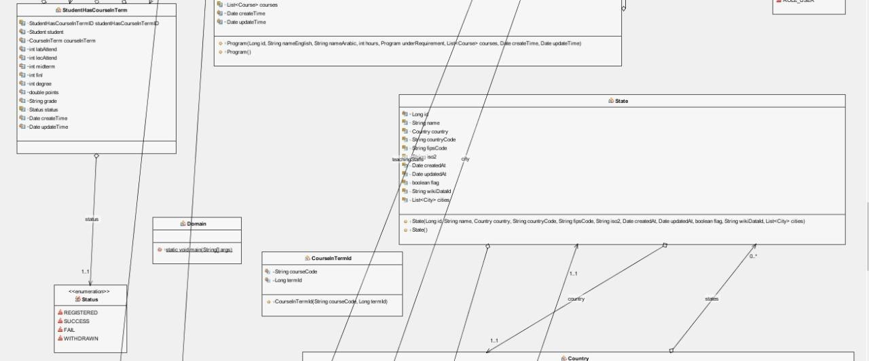

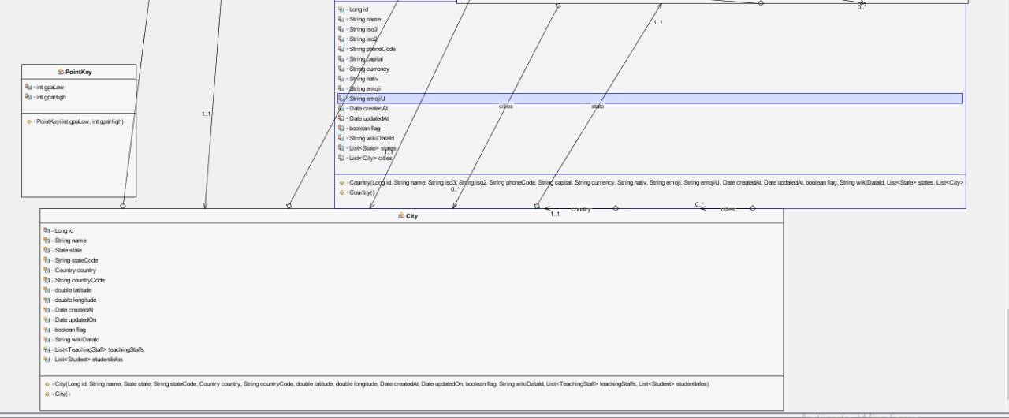

## Software architectural pattern

An architectural pattern is a general, reusable solution to a commonly occurring problem in software architecture within a given context. Architectural patterns are like software design pattern but have a broader scope. The architectural patterns address various issues in software engineering, such as computer hardware performance limitations, high availability and minimization of a business risk. Some architectural patterns have been implemented within software frameworks .

Examples of architectural patterns **:**

- Blackboard system

- Broker pattern

-Event-driven architecture

-Implicit invocation

-Microservices

* Model-view-controller, Presentation- abstraction-control, Model view-presenter, and Model-view-view model
* Operational Data Store (ODS).
* Pipe and filter architecture.
* Service-oriented architecture.

In our Project, we will use Model-view-controller software architecture pattern

**Model–view–controller (MVC):** is a software architectural pattern for implementing user interfaces on computers. It divides a given application into three interconnected parts to separate internal representations of information from the ways that information is presented to and accepted from the user. The MVC design pattern decouples these major components allowing for efficient code reuse and parallel development.

Traditionally used for desktop graphical user interfaces (GUIs), this architecture has become popular for designing web applications and even mobile, desktop and other clients. Popular programming languages like Java, C#, Ruby, PHP and others have popular MVC frameworks that are currently being used in web application development straight out of the box**.**

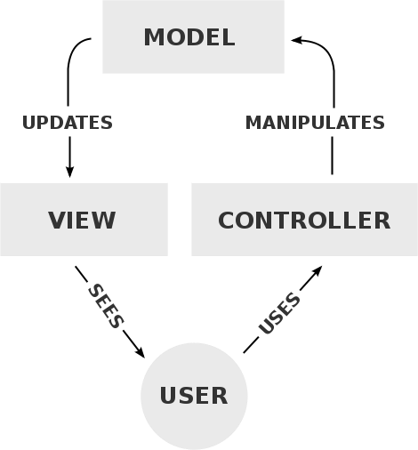

# Chapter 4: Configuration Management

## Mobile Application(Android)

* + 1. **S/W Requirement**

-WINDOWS OS (win7, win8 or win10)

* + - * android studio.
      * MySQL (database).
      * Internet Information Server 5.0 (IIS).
      * Apache server.
      * Linux server.

## H/W Requirements

-PIV 2.8 GHz Processor and Above.

* RAM 512MB and Above.
* HDD 20 GB Hard Disk Space and Above.

## Tools

* + - 1. **JAVA**

Java is an object-oriented programming language developed at Sun. It is now owned, along with the rest of Sun Microsystems, by Oracle. It is, by most accounts, one of the most frequently used programming languages around, and so the skills are available in many individuals offering their services to enterprises. That's very good news. More good news comes from a performance standpoint. Java is a compiled language that can be run in two different ways: either in a browser window or in a virtual machine that doesn't require a browser. That flexibility tends to mean a lot when it comes to re-using code and updating software. If

you're looking at Android as your primary platform you’re almost certainly going to look at Java. If iOS is your main target, you probably won't be doing Java-first development. And if you want to develop a common code base that runs across many different platforms, then Java should certainly be on your list of finalists. I mentioned that we were starting with Java. A quick note on JavaScript: It is, as the name

implies, a scripting language for Web browser apps. It can be useful for adding features to a Web page, but isn't, by itself, the solution you're looking for when it comes to mobile app development. Keep it in mind, though, if you're walking down the HTML5 path**.**

## FLUTTER

Flutter is a free and open-source mobile UI framework created by Google and released in May 2017. In a few words, it allows you to create a native mobile application with only one codebase. This means that you can use one programming language and one codebase to create two different apps (for iOS and Android)

Flutter consists of two important parts:

**-** An SDK (Software Development Kit): A collection of tools that are going to help you develop your applications. This includes tools to compile your code into native machine code (code for iOS and Android)**.**

**-**A Framework (UI Library based on widgets): A collection of reusable UI elements (buttons, text inputs, sliders, and so on) that you can personalize for your own needs .

## Web Application

* + 1. **S/W Requirement**
       - WINDOWS OS (win7, win8 or win10)
       - PHP Storm
       - MySQL (database).
       - Internet Information Server 5.0 (IIS).
       - Apache server.
       - Linux server.

## H/W Requirements

* + - * PIV 2.8 GHz Processor and Above.
      * RAM 512MB and Above.
      * HDD 20 GB Hard Disk Space and Above.

## Tools

### HTML5

If you want to build a Web-fronted app for mobile devices, the one near certainty is HTML5. The eventual standard will make various data types simple to insert, rationalize input parameters, level the browser playing field, account for different screen sizes, and probably freshen your breath and give you lush, manageable hair. Eventually.

The problem is that HTML5 is still a proposed standard that is

currently supported in a lot of different ways by a lot of

different browsers. It’s certainly possible to write HTML5 Web pages now, and many people are doing just that. They just have to know that there might be slight tweaks in the language in months to come and more substantial changes in the way browsers handle HTML5.

From a cost and efficiency standpoint HTML5 has the advantage of building on the current version of HTML so the learning curve is much shallower than that for a completely new language. If you can cope with a bit of uncertainty and want to walk the browser-based path, HTML5 is an obvious choice for a primary language.

### CSS

CSS or Cascading Style Sheets is rather a markup language. When paired with HTML, CSS allow a developer to decide and define how a web page or a website will eventually look or how it will appear to the visitors of the web platform. Some of the elements which CSS has an impact on include font size, font style, the overall layout, the colors and other design elements. This is a markup language that can be applied to several types of documents including Plain XML documents, SVG documents as well as XUL documents. For most websites across the world, CSS is the platform to opt for if they need help to create visually attractive webpages and finds use not just in the creation of web applications but also mobile apps**.** The language’s syntax is pretty similar to that of HTML and

XHTML, which work well in synchronization and combination of one another. The Style sheets included in CSS consist of a selector and a declarator. The simple syntax of the language uses several English language words to define the styling properties.

### JavaScript

JavaScript is one of the most popular and dynamic programming languages used for creating and developing websites. This language is capable of achieving several things including controlling the browser, editing content on a document that has been displayed, allowing client-side scripts to communicate with users and also asynchronous communication. It was developed by Netscape and borrows a lot of its syntax from C language. JavaScript is used very widely and effectively in creating desktop applications as well as for developing games.

One of the best things about JavaScript for you as a developer or a website owner is that this is one of the few programming languages that are accepted and supported by all the major browsers without the need of any compilers or plug-ins. It can also be worked with on platforms that are not web-based, for example-desktop widgets and PDF docs. This is a multiparadigm language which means that it has a combination of features. Also, JavaScript supports functional and object-oriented programming styles.

The features of a language define the way it will work, the way it responds, how easy is its code and what it can achieve. The following are some of the main features of JavaScript programming language for your reference:

* **Structured –** JavaScript is a highly structured language with a proper and planned syntax that has been derived from C. This language too has a function scoping by it lacks block scoping, unlike C. It too differentiates between statements and expressions, just like the fundamental C web programming platform
* **Dynamic –** The types in JavaScript are not related with variables but with values. This is a dynamic programming language that enables you to test the type of an object in many different ways. Also, this programming language is object-oriented where all the objects are associative arrays

**Functional –** All functions in JavaScript are objects and are all first class. They are associated with their own functions as well as characteristics. For example, a function within a function is called a nested function whereas this language also supports anonymous function**.**

### React JS

is a library built for programming in the JavaScript language specialized for user interfaces built by Facebook, as it

provides a smooth and powerful way to build website interfaces, it allows developers to build a component of web pages once so that Use it multiple times.

React can be used as a base in developing single page or mobile phone applications. Complex React applications often require the use of additional libraries to manage, direct, and interact with the API**.**

## Software Development

We used the water fall model to develop system because all Requirements were known beforehand and the objective of our software development is the computerization/automation of an already existing manual working system.

## Design Constrains

Designing interactive systems with graphic user interfaces is an important step in the development of online devices and websites. Evaluation method is utilized to obtain user feedback on how effective the system is and how easy it is to use, compared to other systems.

To create good software, design constraints and other contingencies need to be addressed.

In this section, we will enumerate all considerations that must be made when creating this project **:**

**-** Must be coded efficiently enough to run well on provided server hardware.

- The database will be created and maintained in a way that makes it of reasonable and manageable size.

### Web Based Product

* + - There are no memory requirements
    - The computers must be equipped with web browsers such as

Internet explorer and mobile must be equipped with android system .

* + - The application must be stored in such a way that allows the client

easy access to it.

* + - Response time for loading the meal should take no longer than five minutes .
    - A general knowledge of basic computer skills is required to use the application**.**

## Design Goals

**-**The design of the web application and mobile application involves the design of the forms for listing the courses, search for courses, display the complete specification for the course, and design a track activity that is easy to use.

* + - * **Design** of an interactive application that enables the

user to filter the Courses based on different parameters.

* + - * **Design** of an application that has features like drag and drop etc.
      * **Design** of application that decreases data transfers between the client and the server.

# Chapter 5: Database

* 1. **Introduction**

After the completion of the system analysis it is time to step into the design stage. Once the data are analyzed, and the relationships between the data understood, the E-R model is established, and then the concept structure and logic structure of database designed.

Because SQL Server 2008 can be completed with high efficiency to a variety of database queries, and can facilitate the use of stored procedures, and its graphical user interface allows intuitive and simple system and database, it was used for storage management and maintenance in this project. In addition, due to the support of web technology, SQL Server 2008 allows users to easily publish data in the database on the Web page .

The advantages and disadvantages of the system database design affect the website data connection speed and the complexity of an update query directly**.**

This section describes the design of a system from the point of view of

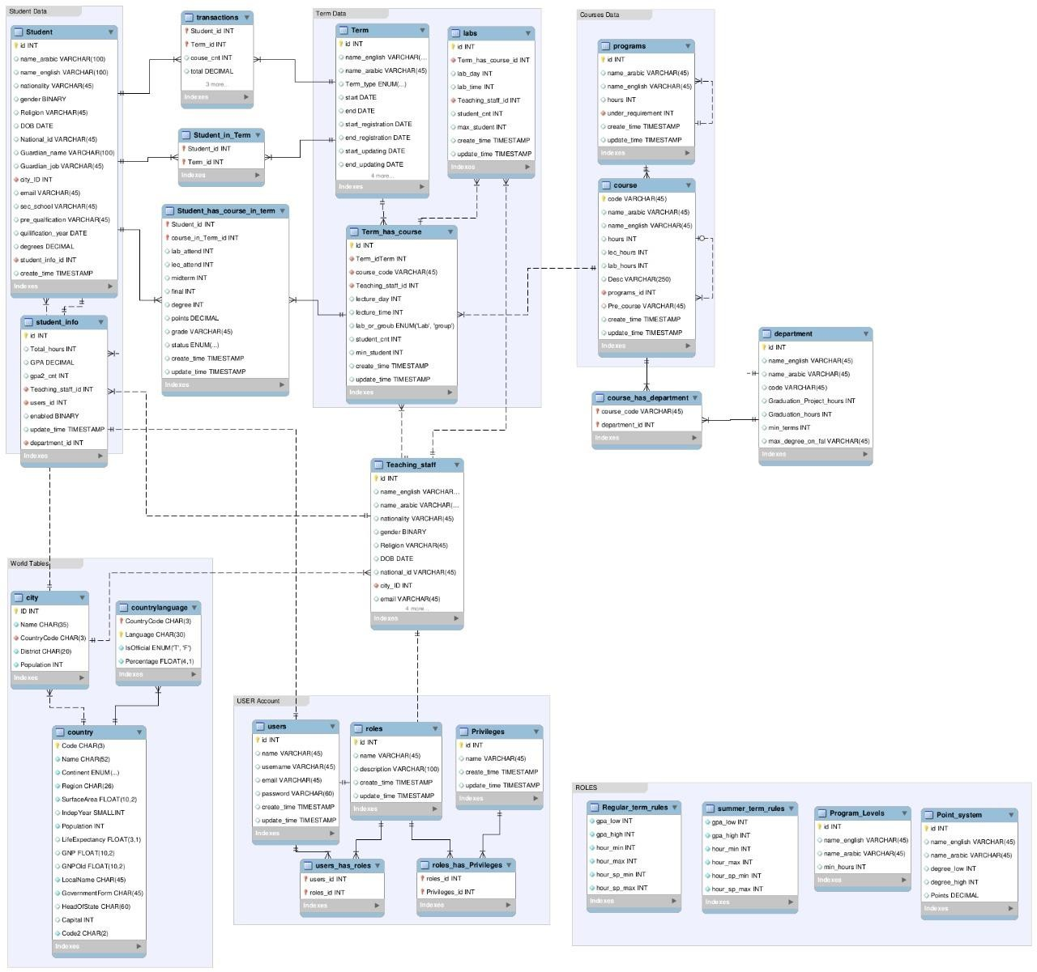

the overall structure of the database and relationship of database table**.**

# ERD

# Chapter 6: Testing

Software testing is an investigation conducted to provide stakeholders with information about the quality of the software product or service under test. Software testing can also provide an objective, independent view of the software to allow the business to appreciate and understand the risks of software implementation. Test techniques include the process of executing a program or application with the intent of finding software bugs (errors or other defects), and verifying that the software product is fit for use .

Software testing involves the execution of a software component or system component to evaluate one or more properties of interest. In general, these properties indicate the extent to which the component or system under test:

- meets the requirements that guided its design and development

* responds correctly to all kinds of inputs
* performs its functions within an acceptable time.
* is sufficiently usable
* can be installed and run in its intended environments, and achieves the general result its stakeholders desire.

As the number of possible tests for even simple software components

is practically infinite, all software testing uses some strategy to select tests that are feasible for the available time and resources. As a result, software testing typically (but not exclusively) attempts to execute a program or application with the intent of finding software bugs (errors or other defects). The job of testing is an iterative process as when one bug is fixed, it can illuminate other, deeper bugs, or can even create new ones**.**

Software testing can provide objective, independent information about the quality of software and risk of its failure to users or sponsors.

Software testing can be conducted as soon as executable software (even if partially complete) exists **.**

### Testing Methods

* + 1. **Static vs. dynamic testing**

There are many approaches available in software testing. Reviews, walkthroughs, or inspections are referred to as static testing, whereas executing programmed code with a given set of test cases is referred to as dynamic testing**.**

Static testing is often implicit, as proofreading, plus when programming tools/text editors check source code structure or compilers (pre-compilers) check syntax and data flow as static program analysis.

Dynamic testing takes place when the program itself is run. Dynamic testing may begin before the program is 100% complete to test sections of code and are applied to discrete functions or modules.

Typical techniques for this are either using stubs/drivers or execution from a debugger environment.

Static testing involves verification, whereas dynamic testing involves validation.

Together they help improve software quality. Among the techniques for static analysis, mutation testing can be used to ensure the test cases will detect errors which are introduced by mutating the source code**.**

### Box Approaches

Software testing methods are traditionally divided into white- and black box testing. These two approaches are used to describe the point of view that a test engineer takes when designing test cases.

### White-box testing

White-box testing (also known as clear box testing, glass box testing, transparent box testing and structural testing, by seeing the source code) tests internal structures or workings

of a program, as opposed to the functionality exposed to the end-user. In white-box testing an internal perspective of the system, as well as programming skills, are used to design test cases. The tester chooses inputs to exercise paths through the code and determine the appropriate outputs. This is analogous to testing nodes in a circuit, e.g. in-circuit testing (ICT)**.**

While white-box testing can be applied at the unit, integration and system levels of the software testing process, it is usually done at the unit level. It can test paths within a unit, paths between units during integration, and between subsystems during a system–level test. Though this method of test design can uncover many errors or problems, it might not detect unimplemented parts of the specification or missing requirements **.**

Techniques used in white-box testing include:

* API testing – testing of the application using public and private APIs (application programming interfaces).
* Code coverage – creating tests to satisfy some criteria of code coverage (e.g., the test designer can create tests to cause all statements in the program to be executed at least once.
* Fault injection methods – intentionally introducing faults to gauge the efficacy of testing strategies.

- Mutation testing methods.

- Static testing methods.

- Code coverage tools can evaluate the completeness of a test suite that was created with any method, including black-box testing. This allows the software team to examine parts

of a system that are rarely tested and ensures that the most important function points have been tested.

Code coverage as a software metric can be reported as a percentage for:

* Function coverage, which reports on functions executed
* Statement coverage, which reports on the number of lines executed to complete the test.
* Decision coverage, which reports on whether both the True and the False branch of a given test has been executed.

100% statement coverage ensures that all code paths or branches (in terms of control flow) are executed at least once. This is helpful in ensuring correct functionality, but not sufficient since the same code may process different inputs correctly or incorrectly.

### Black-box testing

Black-box testing treats the software as a "black box", examining functionality without any knowledge of internal implementation, without seeing the source code. The testers

are only aware of what the software is supposed to do, not how it does it.

Black-box testing methods include: equivalence partitioning, boundary value analysis, all-pairs testing, state transition tables, decision table testing, fuzz testing, model-based testing, use case testing, exploratory testing and specification-based testing**.**

Specification-based testing aims to test the functionality of software according to the applicable requirements**.**

This level of testing usually requires thorough test cases to be provided to the tester, who then can simply verify that for a given input, the output value (or behavior), either "is" or "is not" the same as the expected value specified in the test case. Test cases are built around specifications and requirements, i.e., what the application is supposed to do. It uses external descriptions of the software, including specifications, requirements, and designs to derive test cases. These tests can be functional or nonfunctional, though usually functional **.**

Specification-based testing may be necessary to assure correct functionality, but it is insufficient to guard against complex or high-risk situations .

One advantage of the black box technique is that no programming knowledge is required. Whatever biases the programmers may have had, the tester likely has a different

set and may emphasize different areas of functionality. On the other hand, black-box testing has been said to be "like a walk in a dark labyrinth without a flashlight." Because they do not examine the source code, there are situations when a tester writes many test cases to check something that could have been tested by only one test case, or leaves some parts of the program untested .

This method of test can be applied to all levels of software testing: unit, integration, system and acceptance. It typically comprises most if not all testing at higher levels, but can also dominate unit testing as well.

### Gray-box testing

Grey-box testing (American spelling: gray-box testing) involves having knowledge of internal data structures and algorithms for purposes of designing tests, while executing those tests at the user, or black-box level. The tester is not required to have full access to the software's source code. [not in citation given] Manipulating input data and formatting output do not qualify as grey-box, because the input and output are clearly outside of the "black box" that we are calling the system under test. This distinction is particularly important when conducting integration testing between two modules of code written by two different developers, where only the interfaces are exposed for test.

However, tests that require modifying a back-end data repository such as a database or a log file does qualify as

grey-box, as the user would not normally be able to change the data repository in normal production operations. [citation needed] Grey-box testing may also include reverse engineering to determine, for instance, boundary values or error messages.

By knowing the underlying concepts of how the software works, the tester makes better-informed testing choices while testing the software from outside. Typically, a grey-box tester will be permitted to set up an isolated testing environment with activities such as seeding a database. The tester can observe the state of the product being tested after performing certain actions such as executing SQL statements against the database and then executing queries to ensure that the expected changes have been reflected. Grey-box testing implements intelligent test scenarios, based on limited information. This will particularly apply to data type handling, exception handling, and so on.

In our project, we used White-box testing (also known as clear box testing, glass box testing, transparent box testing and structural testing, by seeing the source code .

## Testing levels

There are generally four recognized levels of tests: unit testing, integration testing, component interface testing, and system testing. Tests are frequently grouped by where they are added in the software development process, or by the level of specificity of the test. The main levels during the development process as defined by the

SWEBOK guide are unit-, integration-, and system testing that are distinguished by the test target without implying a specific process model. Other test levels are classified by the testing objective **.** There are two various levels of tests from the perspective of customers: low level testing (LLT) and high-level testing (HLT). LLT is a group of tests for different level components of software application or product. HLT is a group of tests for the whole software application or product**.**

## Unit testing

Unit testing refers to tests that verify the functionality of a specific section of code, usually at the function level. In an object-oriented environment this is usually at the class level, and the minimal unit tests include the constructors and destructors.

These types of tests are usually written by developers as they work on code (white-box style), to ensure that the specific function is working as expected. One function might have multiple tests, to catch corner cases or other branches in the code. Unit testing alone cannot verify the functionality of a piece of software, but rather is used to ensure that the building blocks of the software work independently from each other.

Unit testing is a software development process that involves synchronized application of a broad spectrum of defect prevention and detection strategies to reduce software development risks, time, and costs. It is performed by the software developer or engineer during the construction phase

of the software development lifecycle. Rather than replace traditional QA focuses, it augments it. Unit testing aims to eliminate construction errors before code is promoted to QA; this strategy is intended to increase the quality of the resulting software as well as the efficiency of the overall development and QA process.

Depending on the organization's expectations for software development, unit testing might include static code analysis, data-flow analysis, metrics analysis, peer code reviews, code coverage analysis and other software verification practices. Example from our unit tests**:**

import org.junit.Test;

import java.util.regex.Pattern;

import static org.junit.Assert.assertFalse; import static org.junit.Assert.assertTrue;

public class EmailValidatorTest {

@Test

public void email Validator _ Correct EmailSimple_ReturnsTrue() {

assertThat(EmailValidator.isValidEmail("[name@gmail.com](mailto:name@gmail.com)"), is(true));

}

}

### Integration testing

Integration testing is any type of software testing that seeks to verify the interfaces between components against a software design.

Software components may be integrated in an iterative way or all

together ("big bang"). Normally the former is considered a better practice since it allows interface issues to be located more quickly and fixed.

Integration testing works to expose defects in the interfaces and interaction between integrated components (modules). Progressively larger groups of tested software components corresponding to elements of the architectural design are integrated and tested until the software works as a system.

Example from our integration tests:

@Test

public void testWithBoundService() throws TimeoutException {

// Create the service Intent. Intent serviceIntent =

new Intent(InstrumentationRegistry.getTargetContext(), LocalService.class);

// Data can be passed to the service via the Intent. serviceIntent.putExtra(LocalService.SEED_KEY, 42L);

// Bind the service and grab a reference to the binder. IBinder binder = mServiceRule.bindService(serviceIntent);

// Get the reference to the service, or you can call

// public methods on the binder directly. LocalService service =

((LocalService.LocalBinder) binder).getService();

// Verify that the service is working correctly. assertThat(service.getRandomInt(), is(any(Integer.class)));

}

onView(withId(R.id.my_view))

.perform(click())

// withId(R.id.my_view) is a ViewMatcher

// click() is a ViewAction

.check(matches(isDisplayed())); // matches(isDisplayed()) is a

ViewAssertion

### Component interface testing

The practice of component interface testing can be used to check the handling of data passed between various units, or subsystem components, beyond full integration testing between those units. The data being passed can be considered as "message packets" and the range or data types can be checked, for data generated from one unit, and tested for validity before being passed into another unit. One option for interface testing is to keep a separate log file of data items being passed, often with a timestamp logged to allow analysis of thousands of cases of data passed between units for days or weeks. Tests can include checking the handling of some extreme data values while other interface variables are passed as normal values. Unusual data values in an interface can help explain unexpected performance in the next unit. Component interface testing is a variation of black-box testing, with the focus on the data values beyond just the related actions of a subsystem component.

Example from our integration tests:

### System testing

System testing tests a completely integrated system to verify that the system meets its requirements.

For example, a system test might involve testing a logon interface, then creating and editing an entry, plus sending or printing results, followed by summary processing or deletion (or archiving) of entries, then logoff.

# Chapter 7: Screen shots of working Apps

* 1. **Web Application**

### home

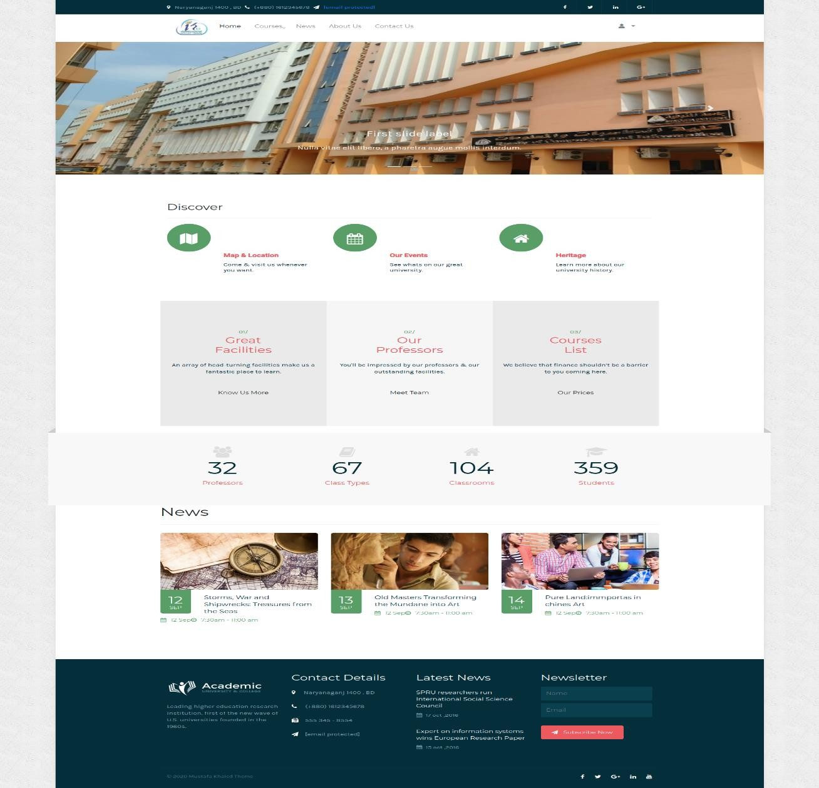

1. **profile**

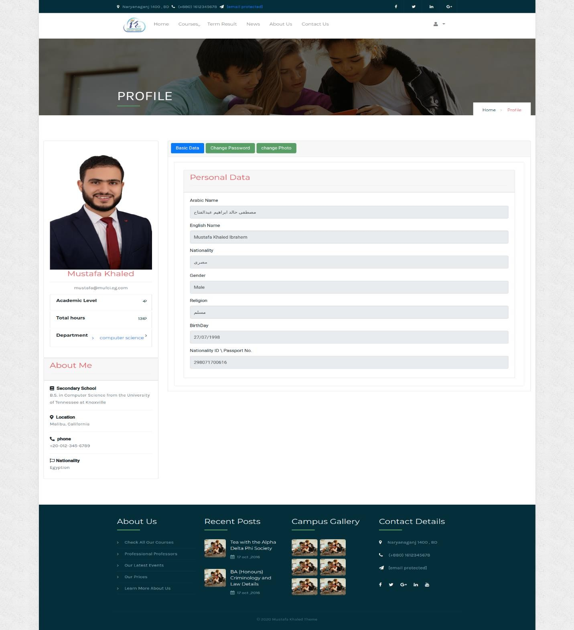

### register courses

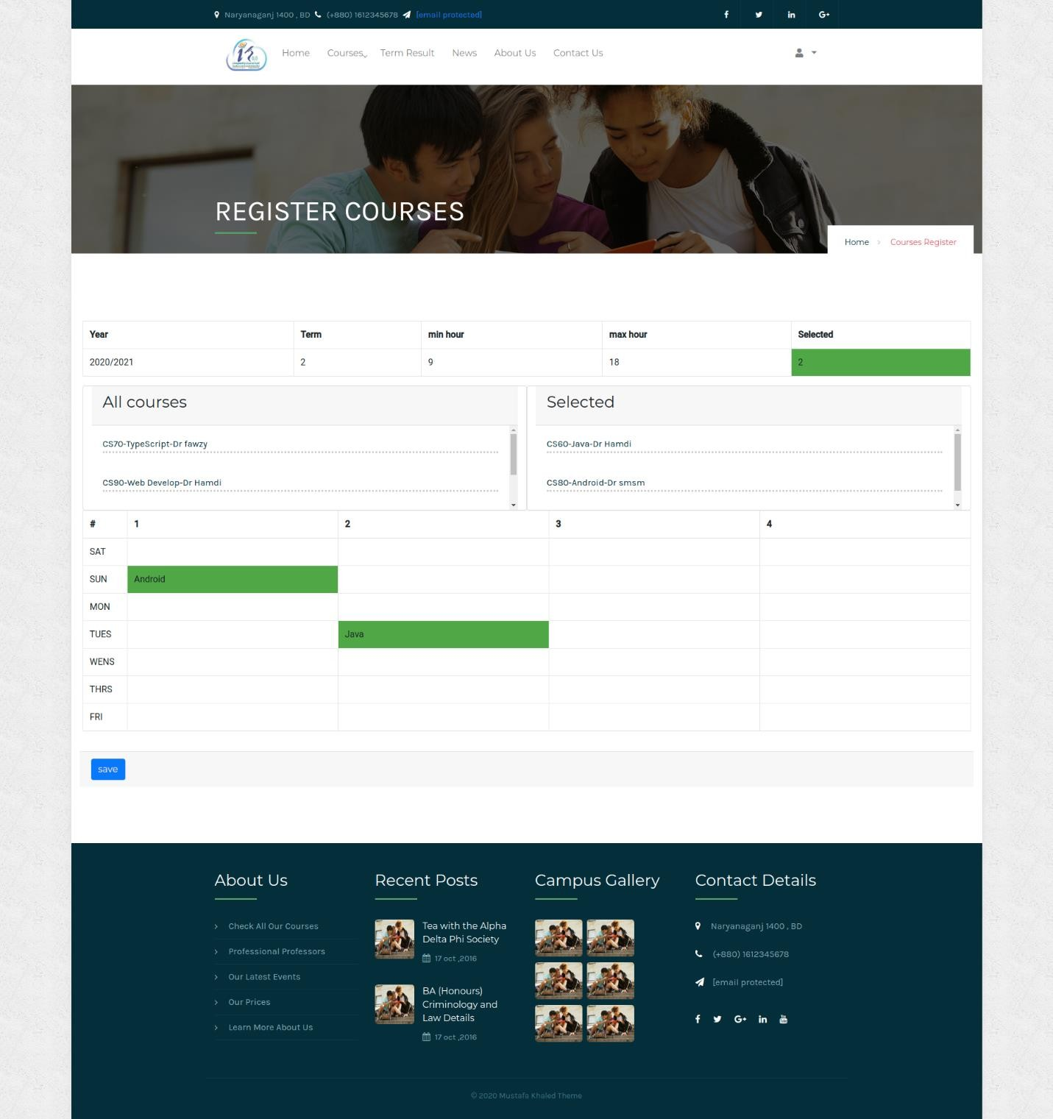

1. **all courses**

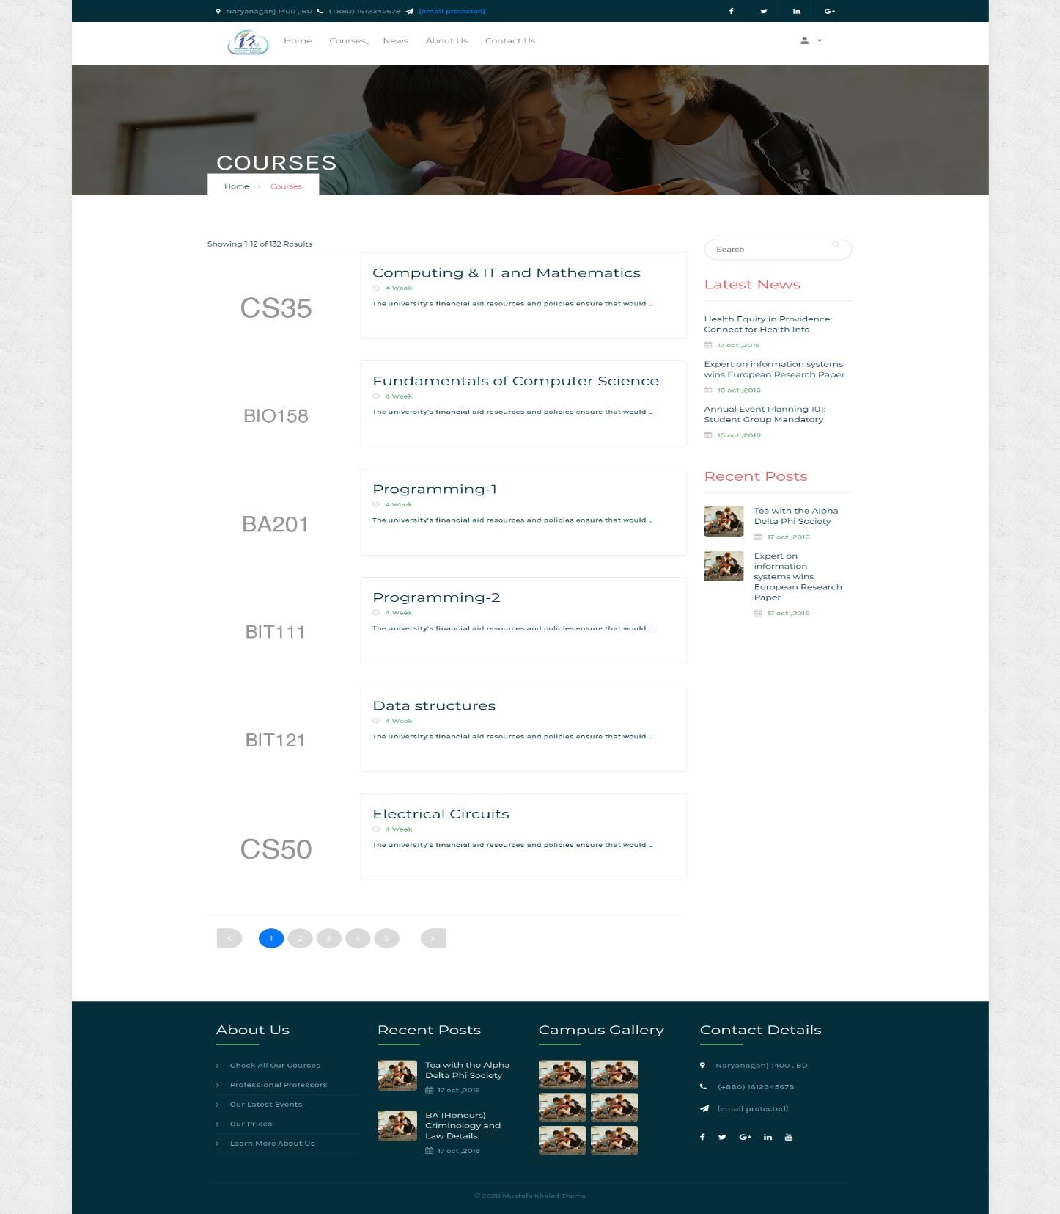

### course material

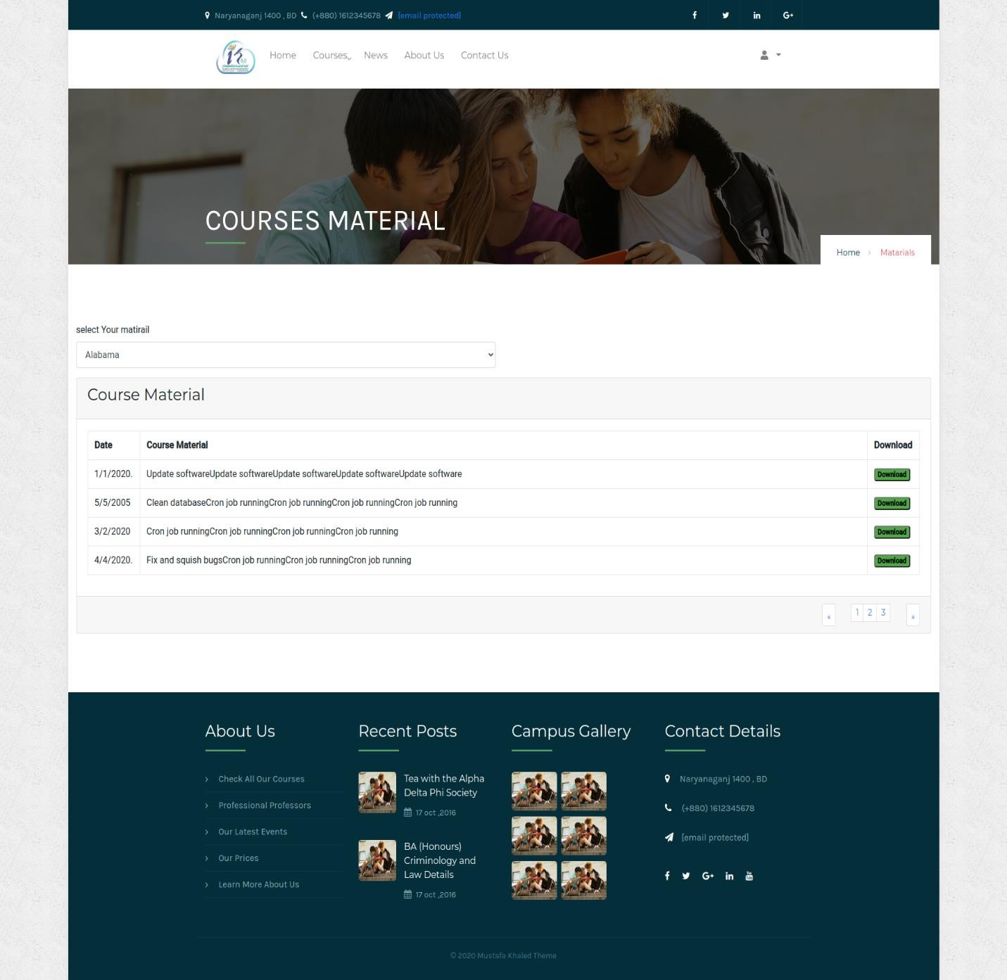

1. **resulte**

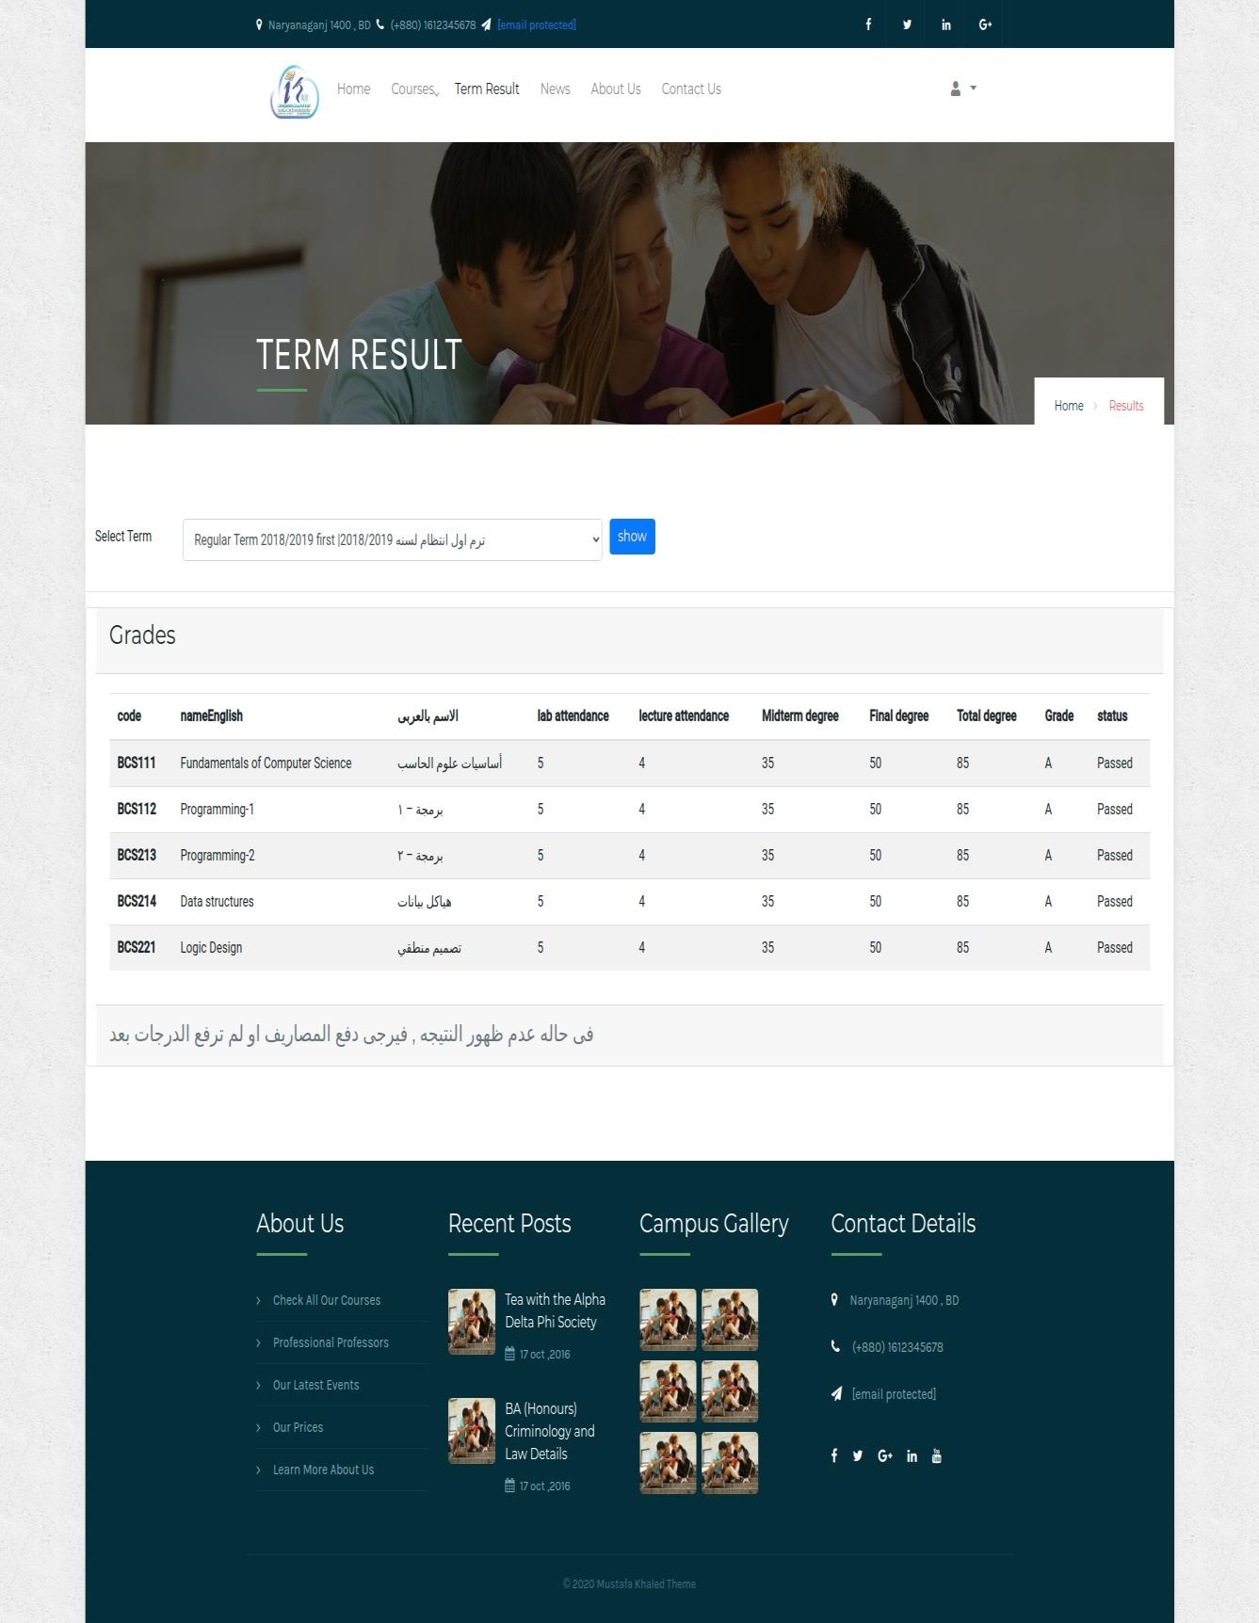

### excuse

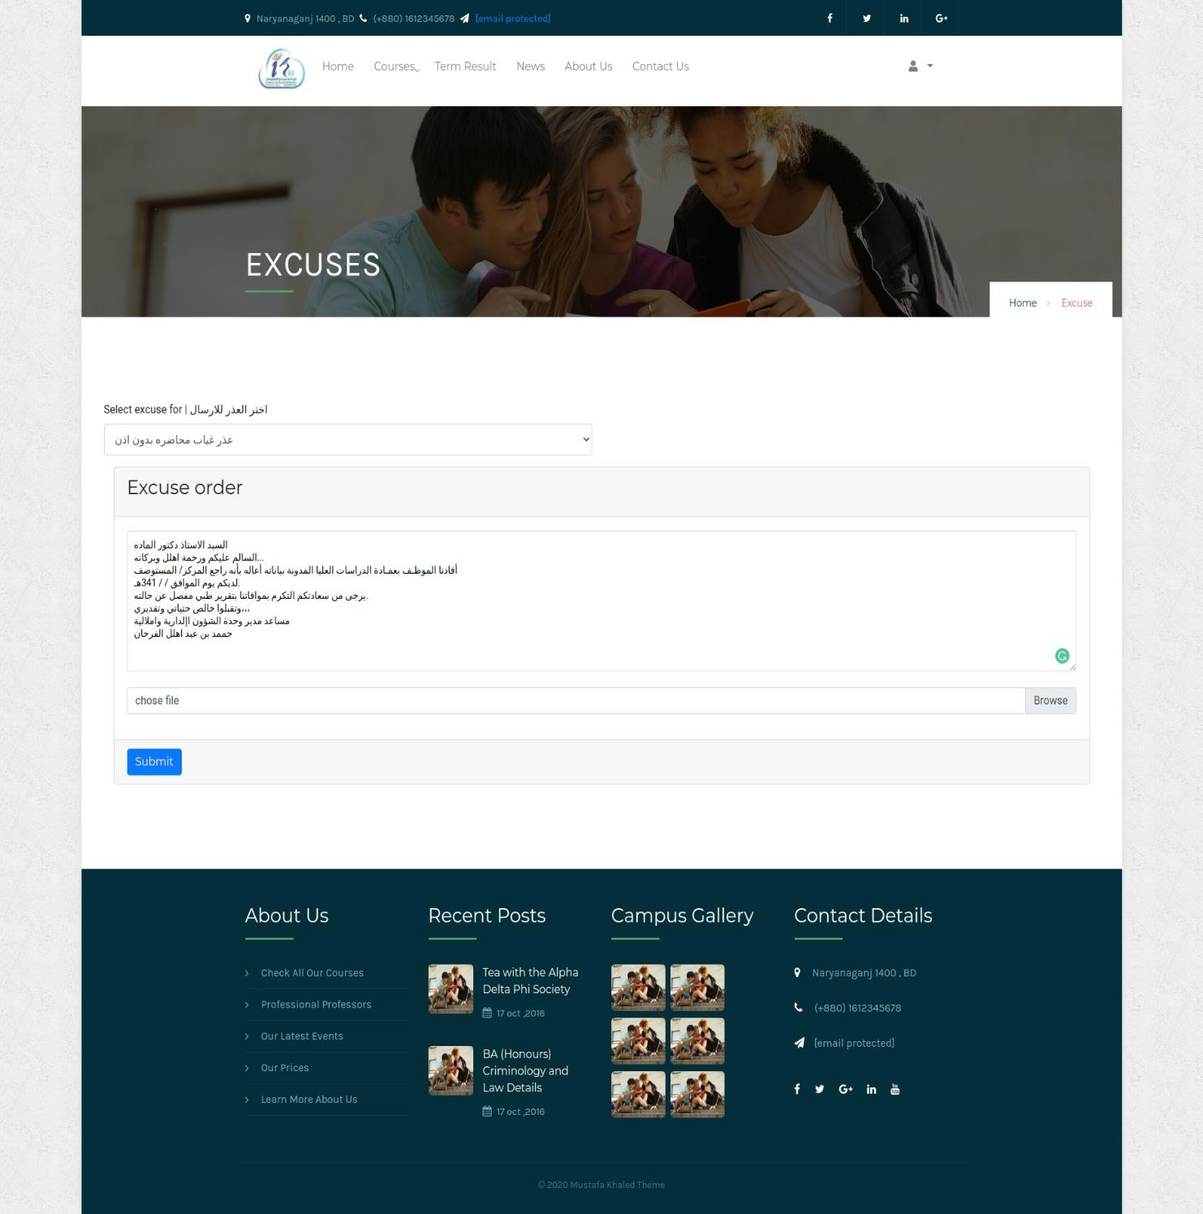

1. **about us**

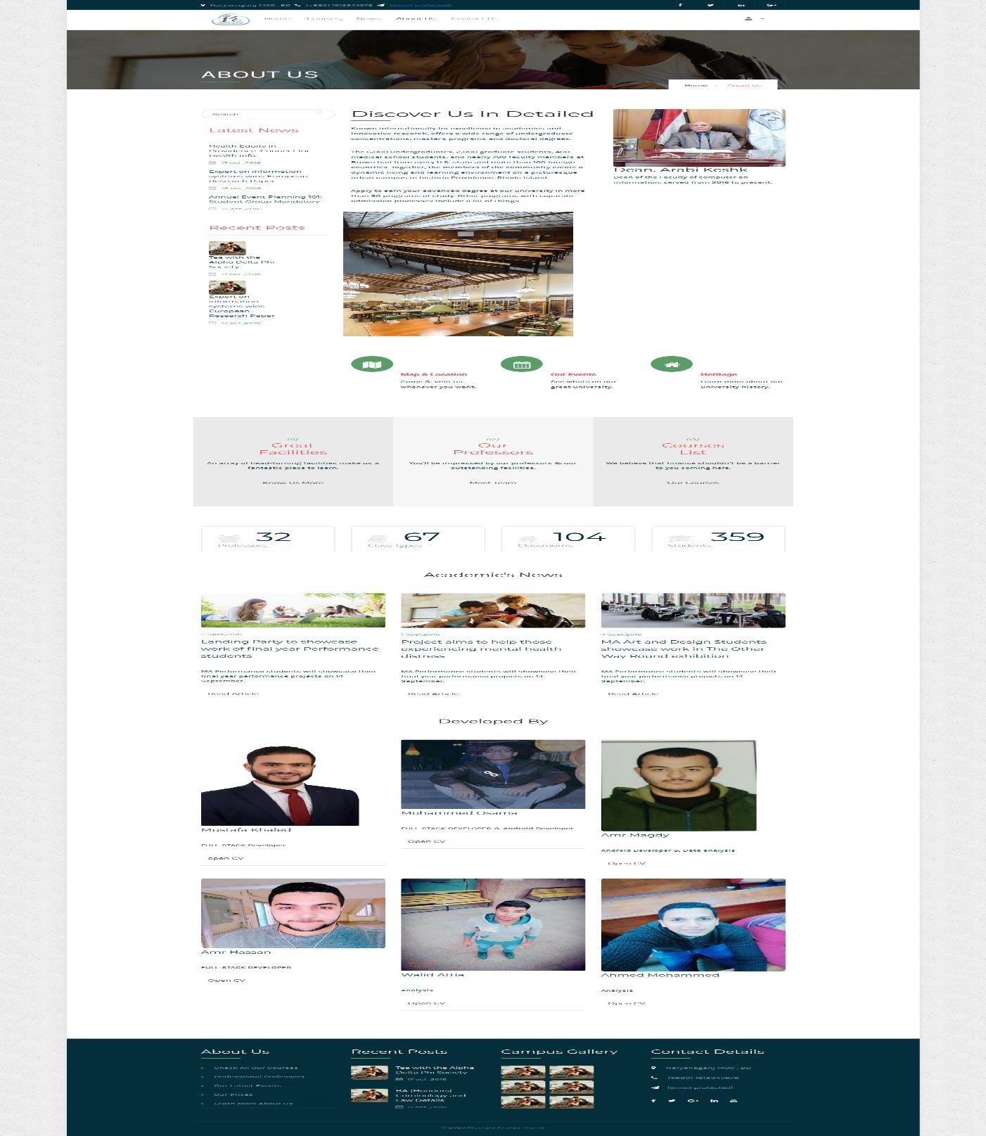

### news

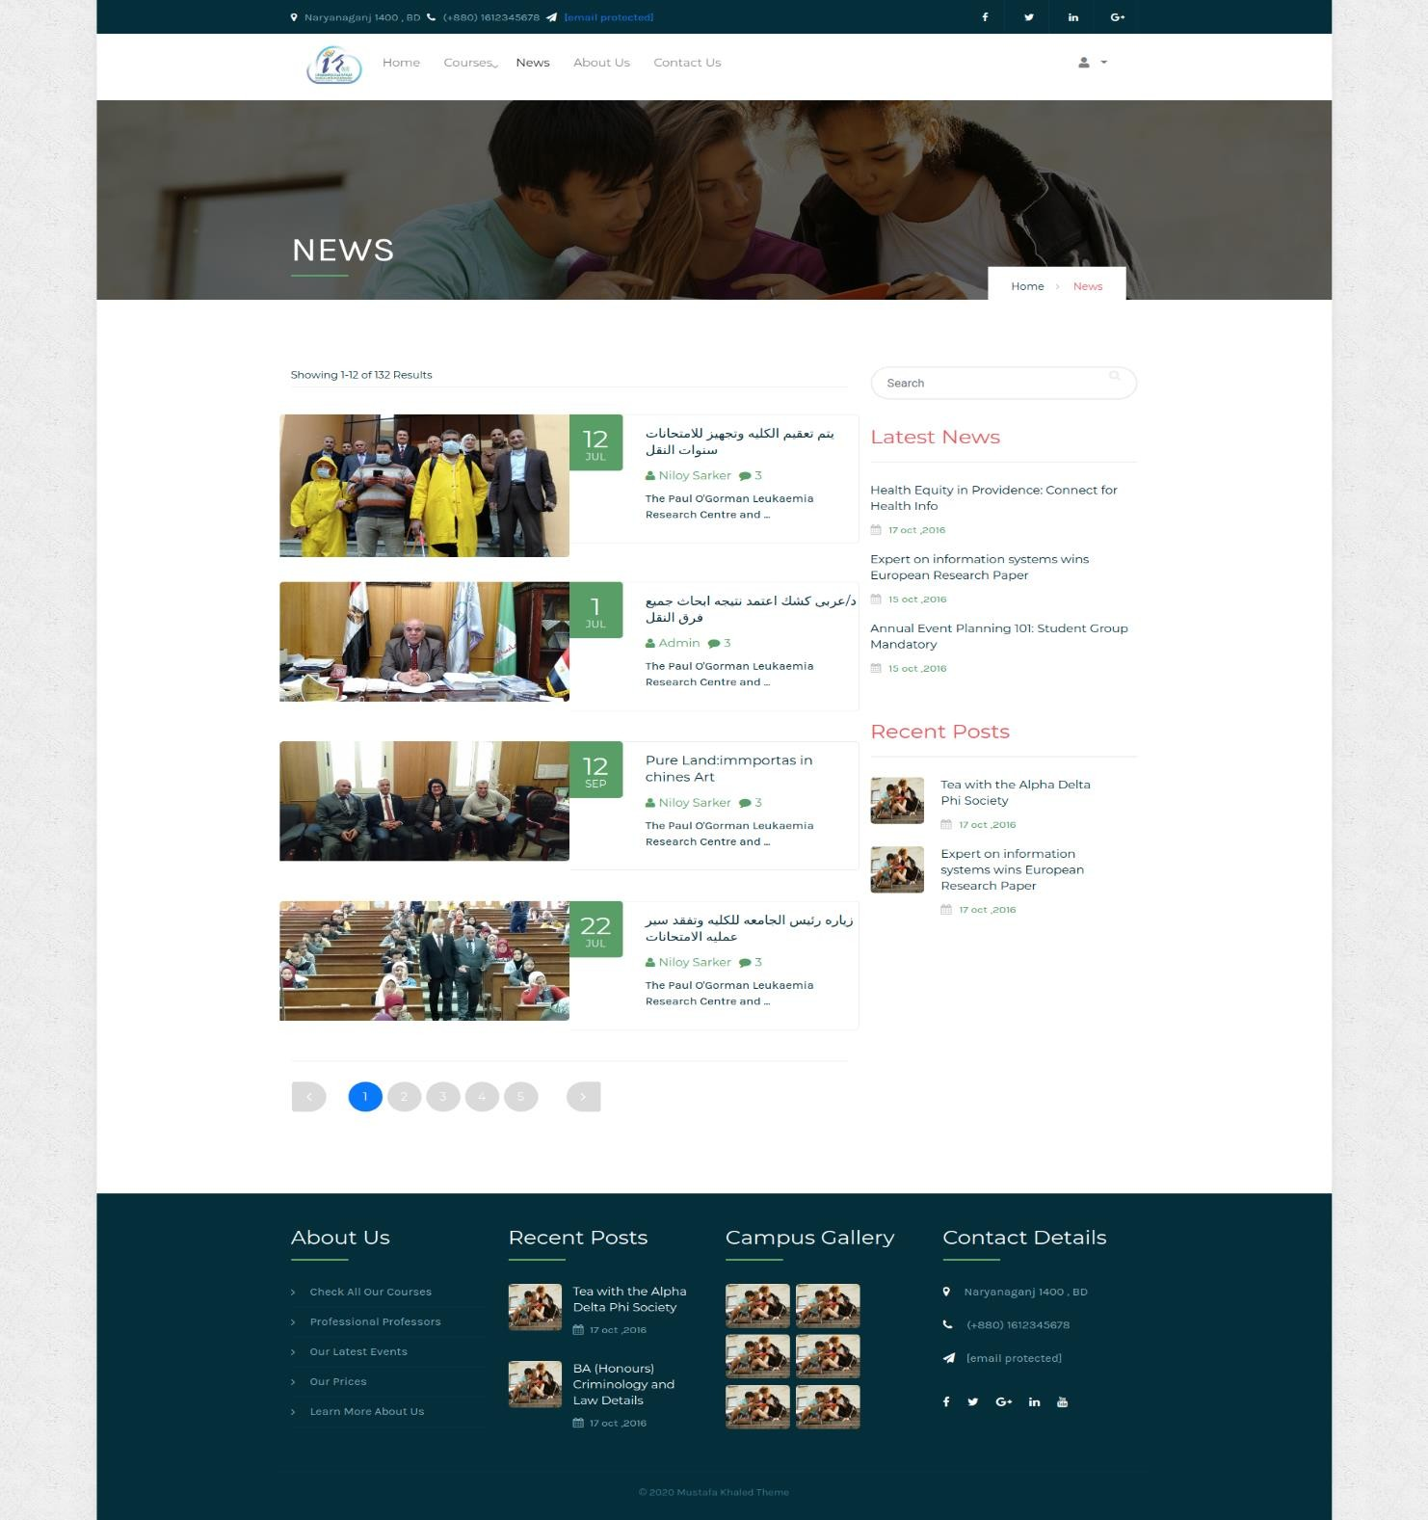

1. **error 404**

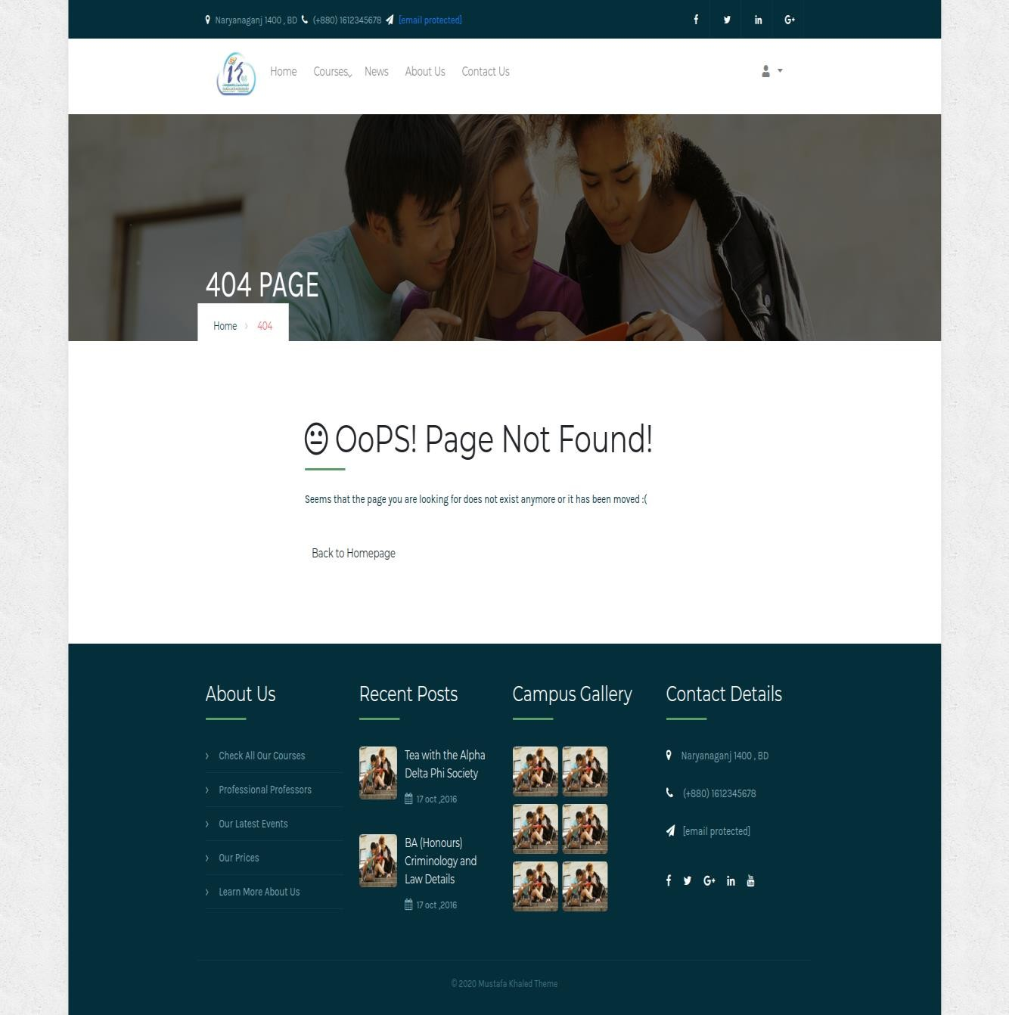

### add courses

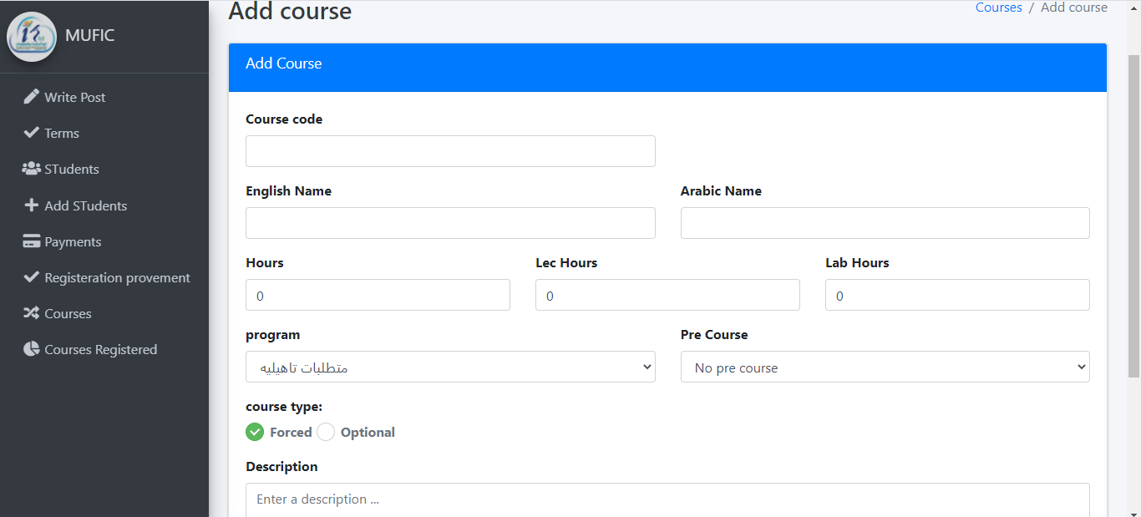

1. **add program**

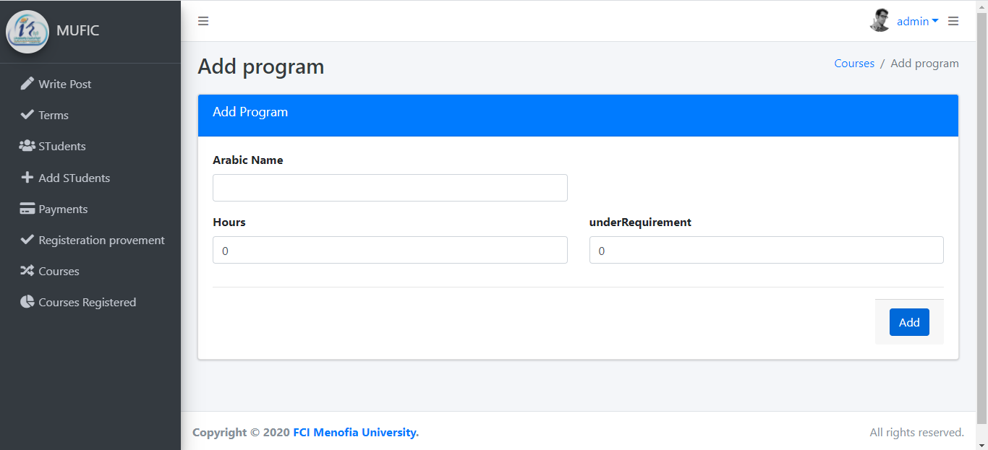

### add terms

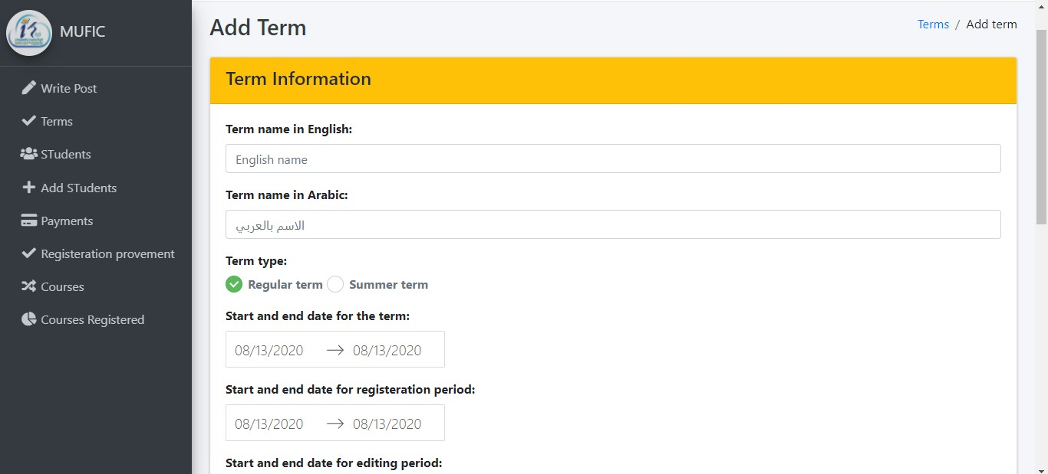

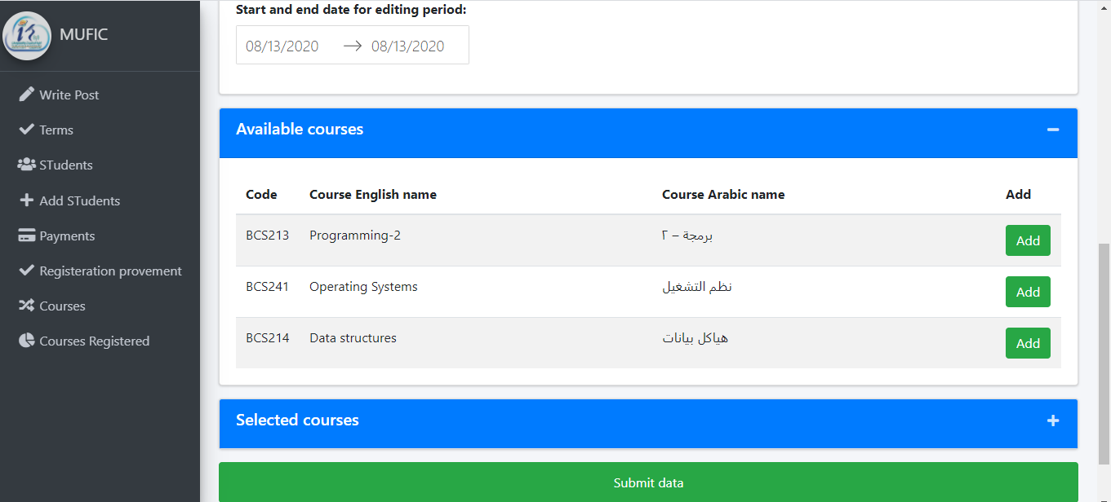

1. **all terms**

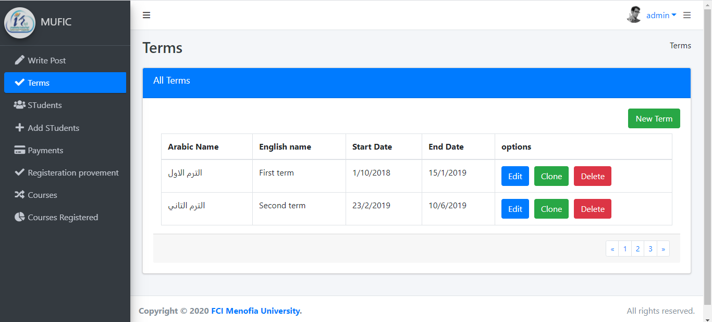

### add student

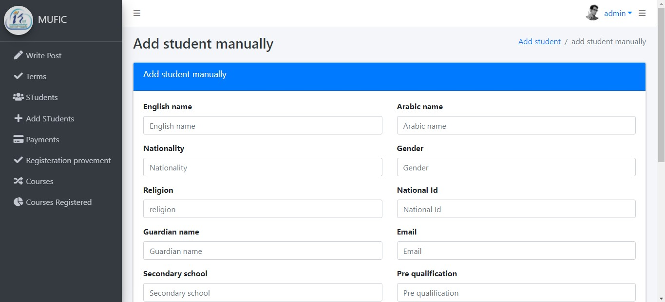

1. **add student**

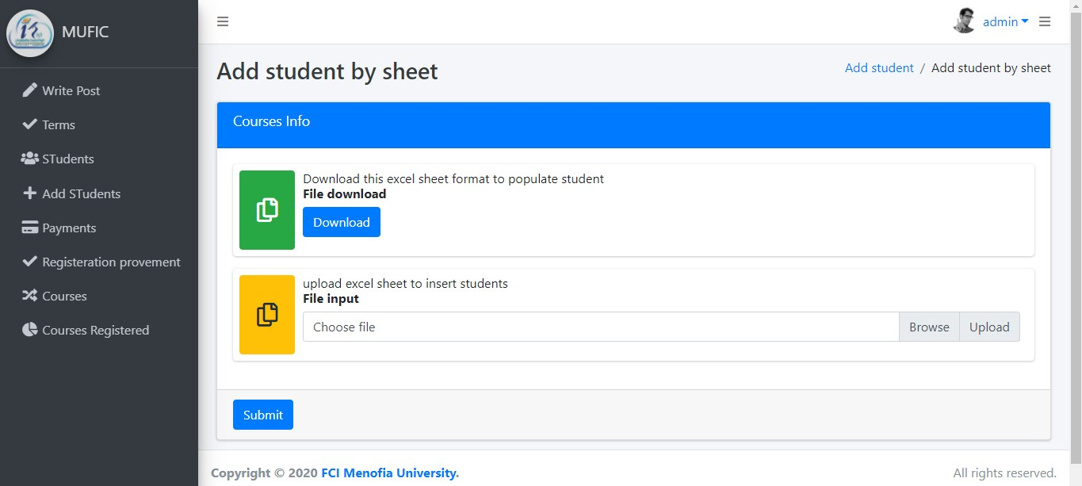

### complete course data

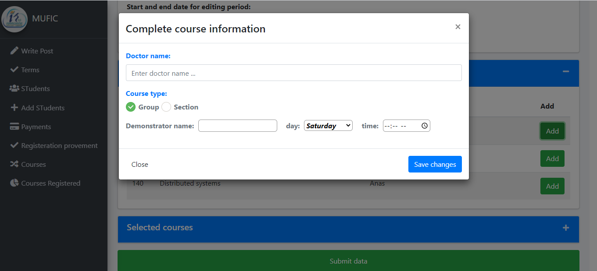

1. **write posts**

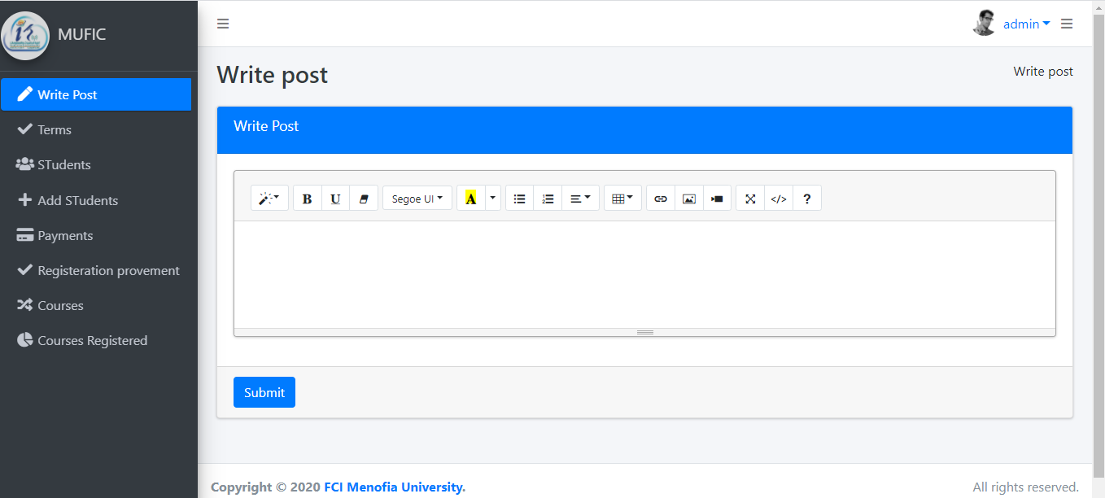

### make proof of registration

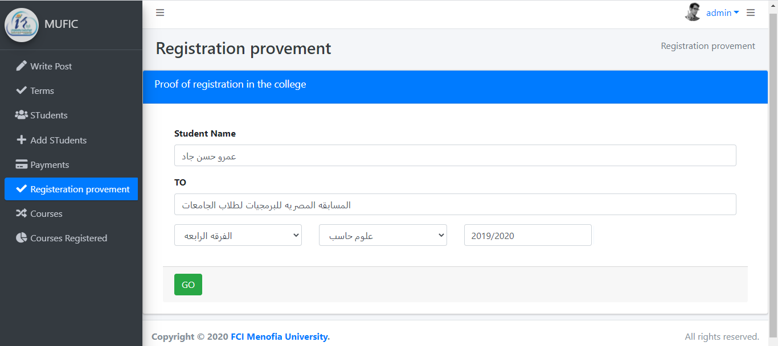

1. **print prof of registration**

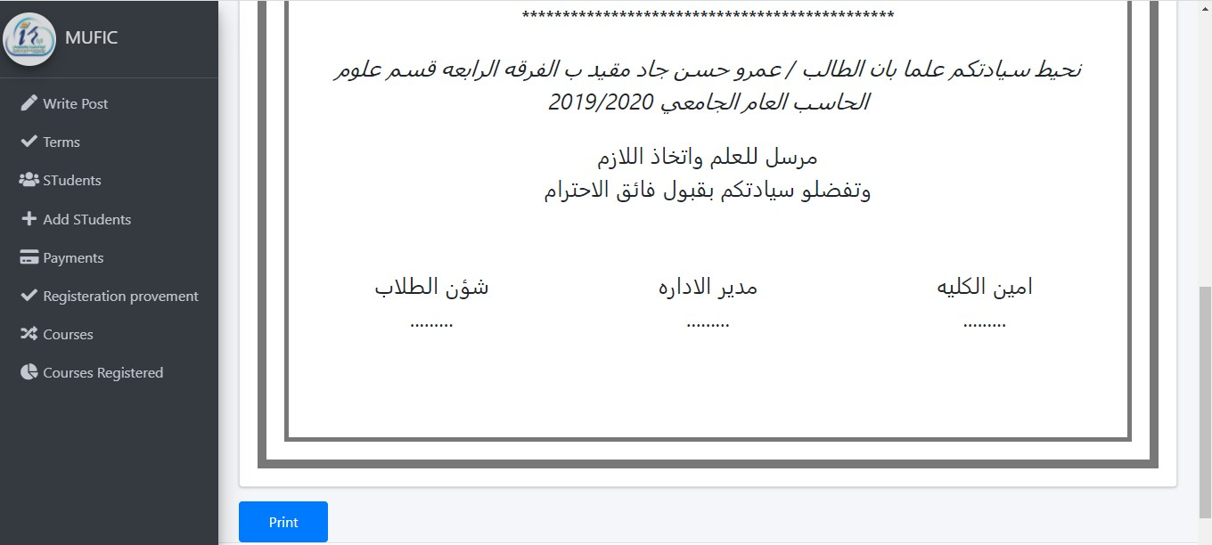

### see registered course

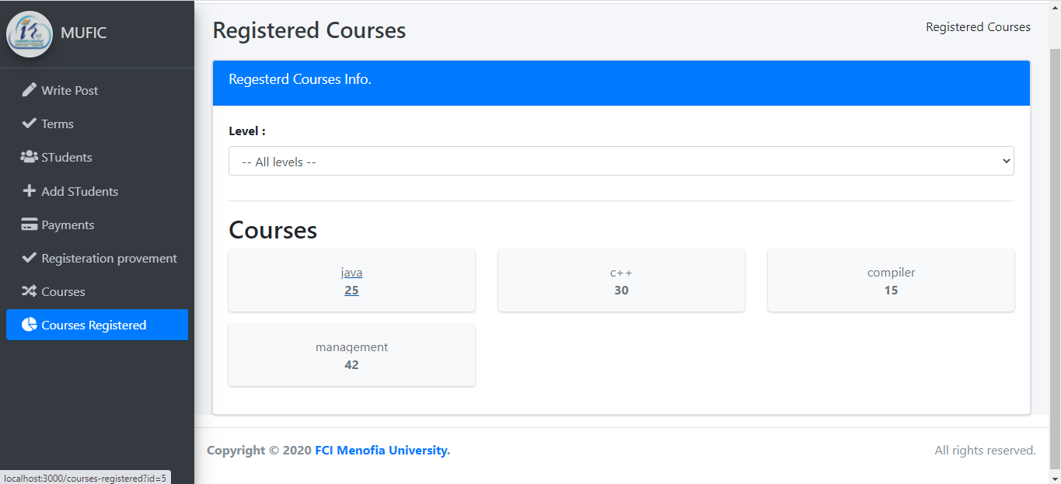

1. **show current course**

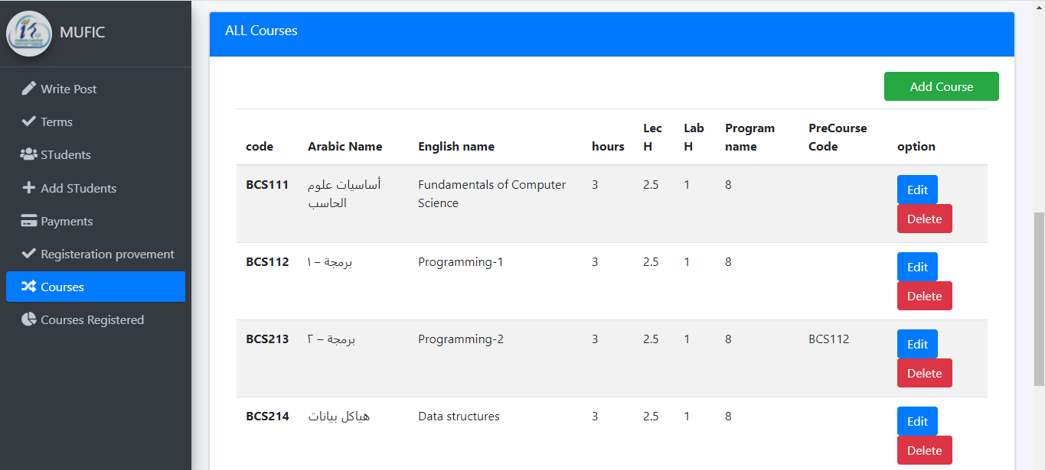

### show current program

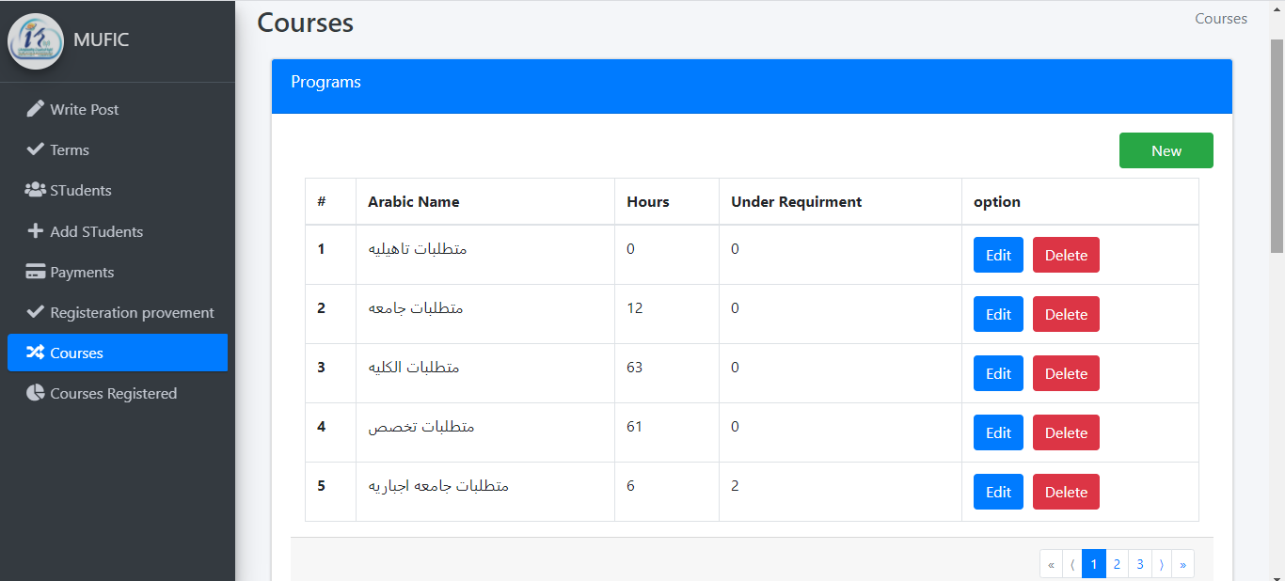

1. **show student**

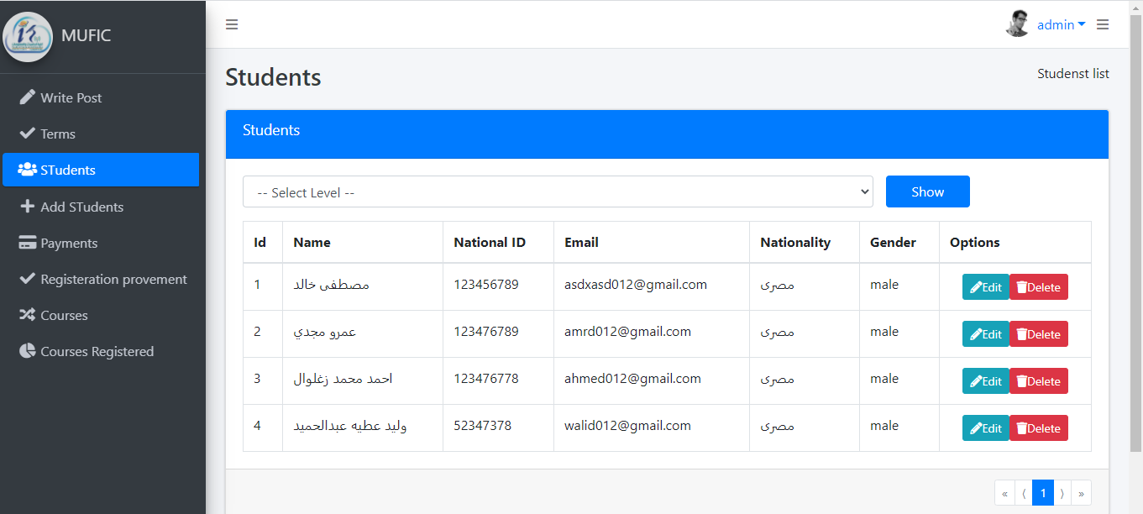

1. **upload material**

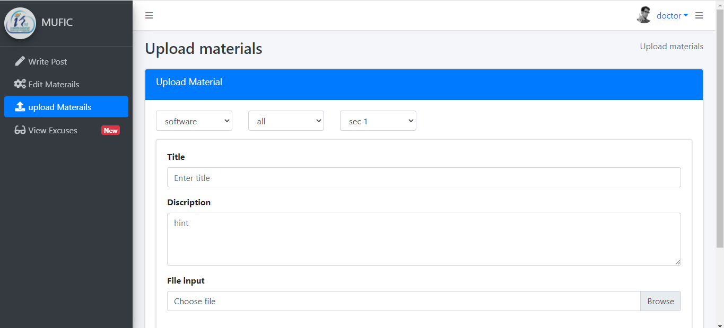

# Mobile Application

### login

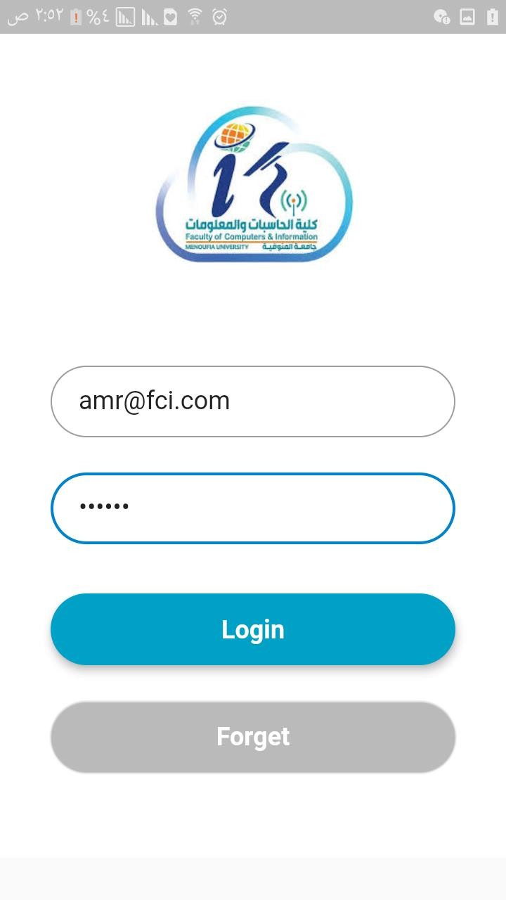

login with e-mail and password

### Home

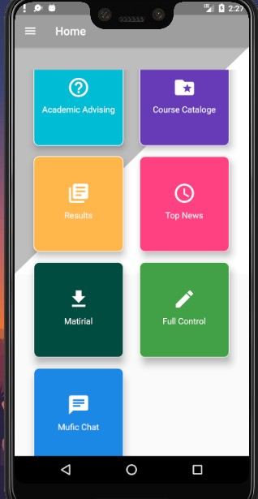

home page contain 6 card view which make student can to navigate in app easier

### profile

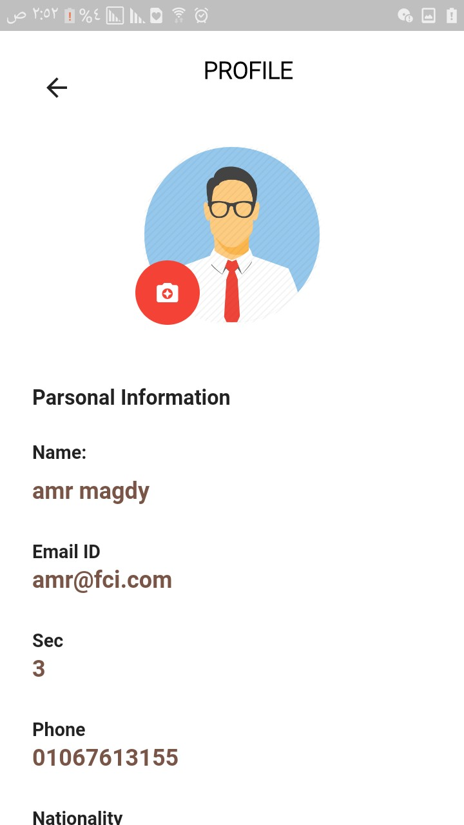

user profile contain his picture and more information like his name ,email ID ,section number ,phone number ,address and

birthday date.

### nave bar

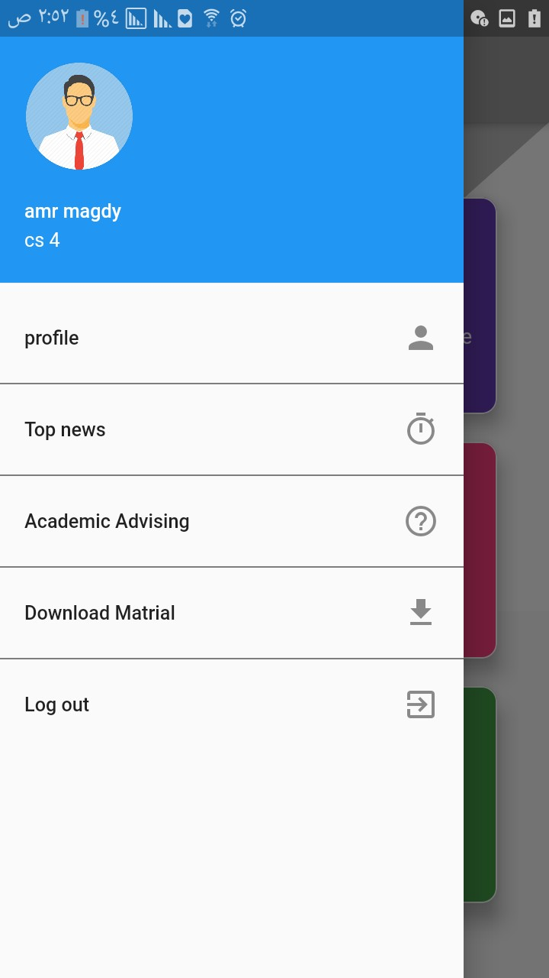

nave bar make user navigate in his profile more easier

### offline guide

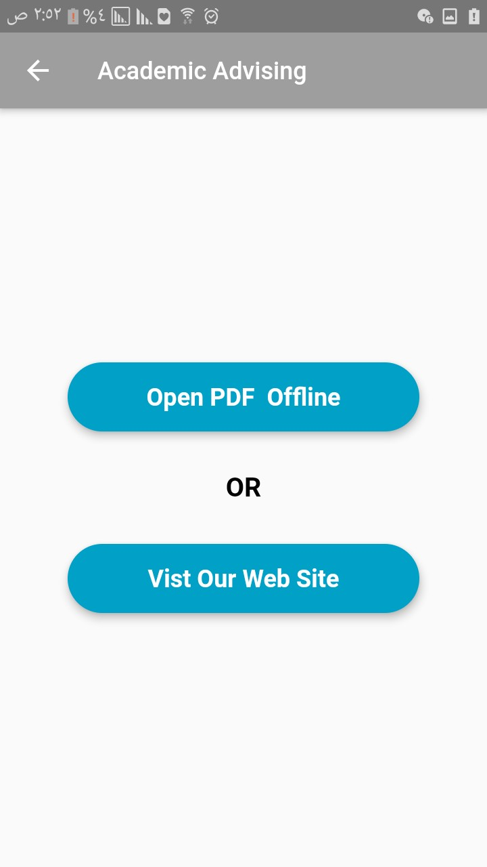

user has offline guide to help him to get rules offline without internet connection and a link to get web site

### offline PDF

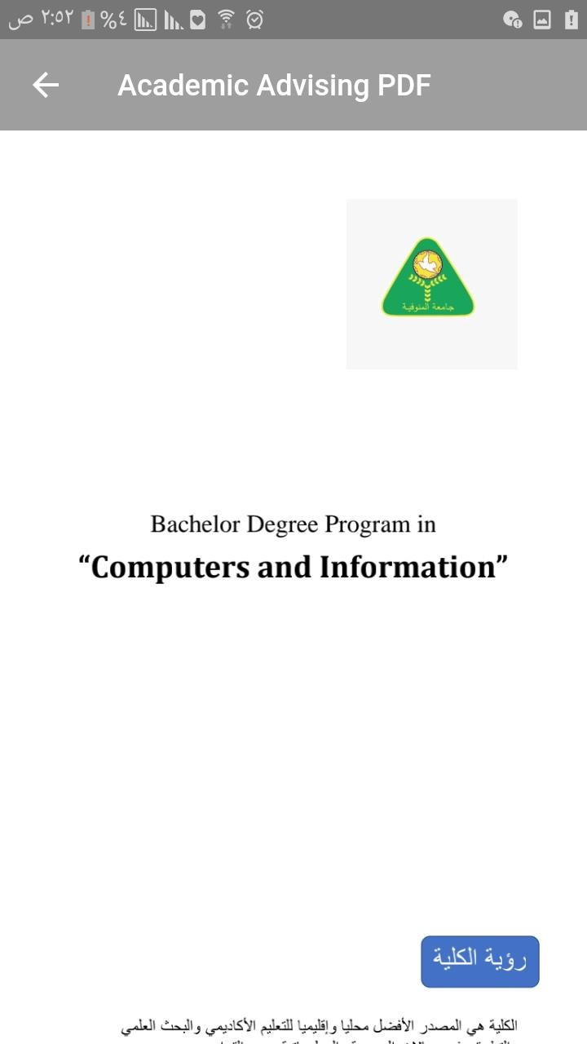

offline PDF which show the rules of college

### Grade

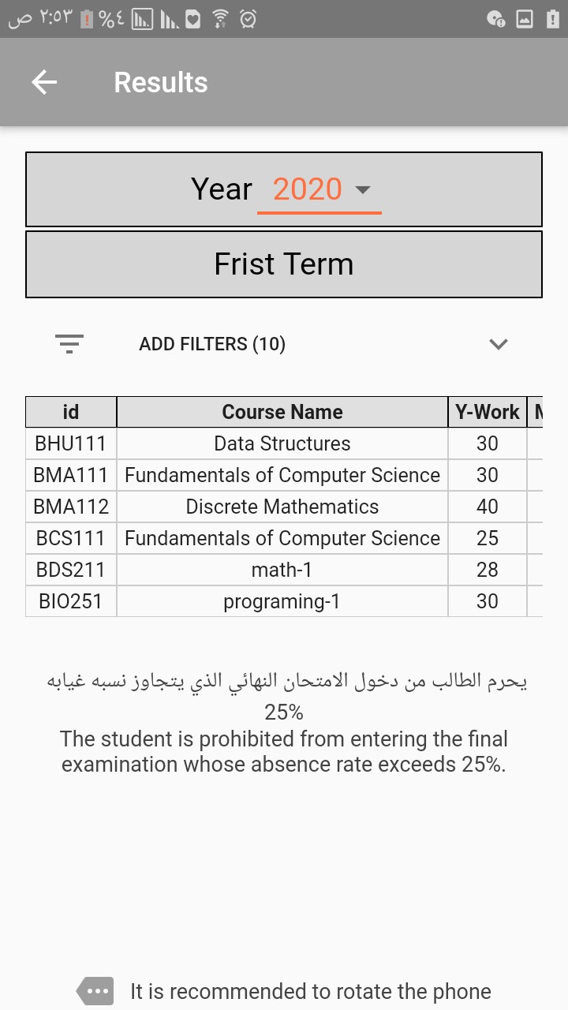

**displaying the grade of student with a lot of options in display**

### Grade

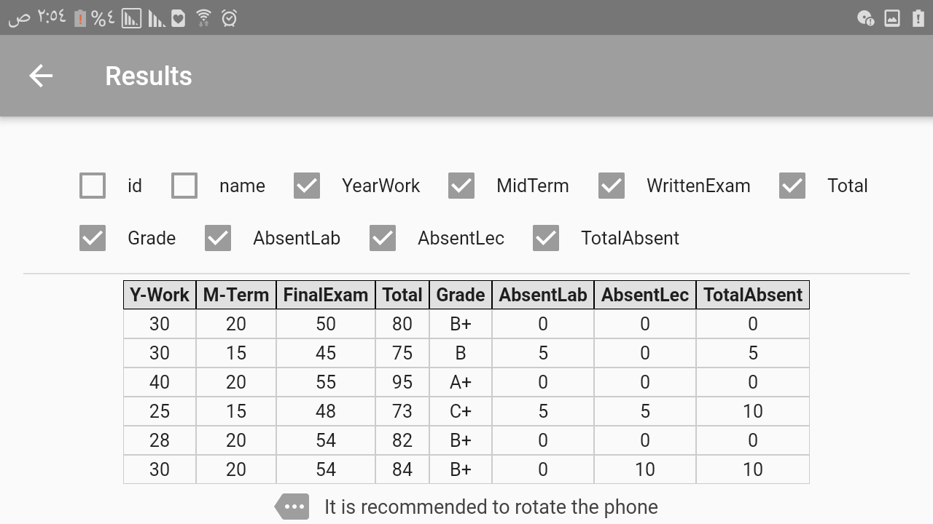

using filter option in displaying the grade

### All courses

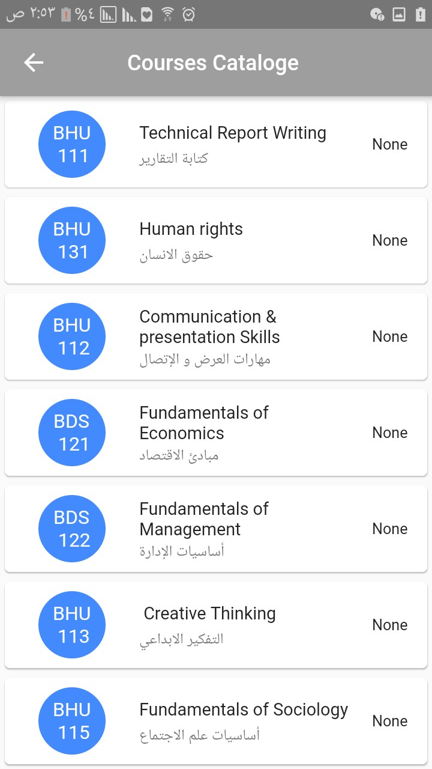

courses catalog to display information of courses like it’s name

, course ID and pre courses**.**

### Lecture

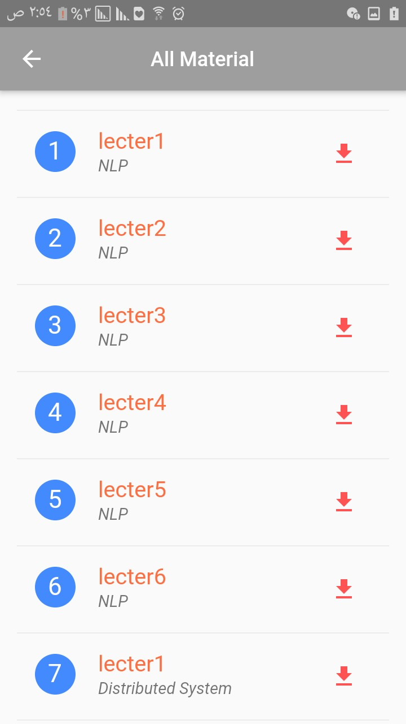

courses material student can get it and download it **.**

### course info

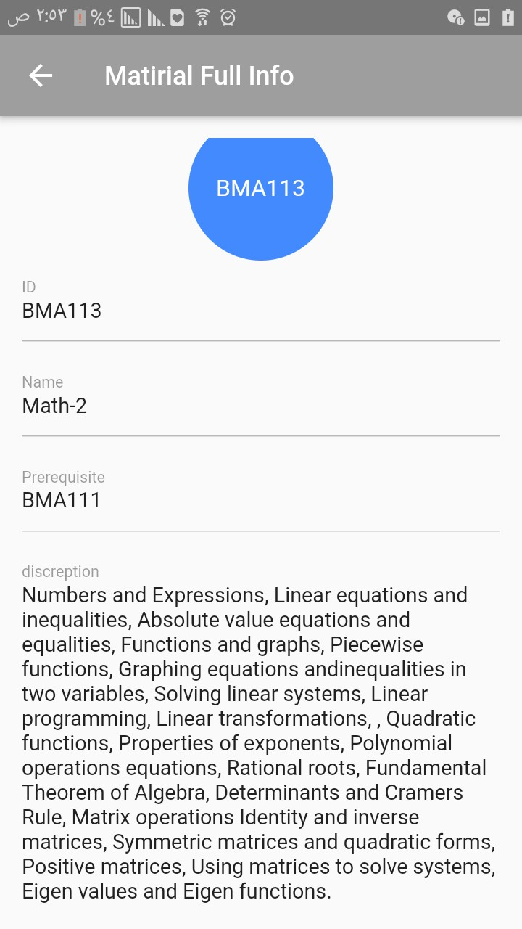

courses info like it’s name , ID , pre courses and number of hours**.**

### Courses PDF

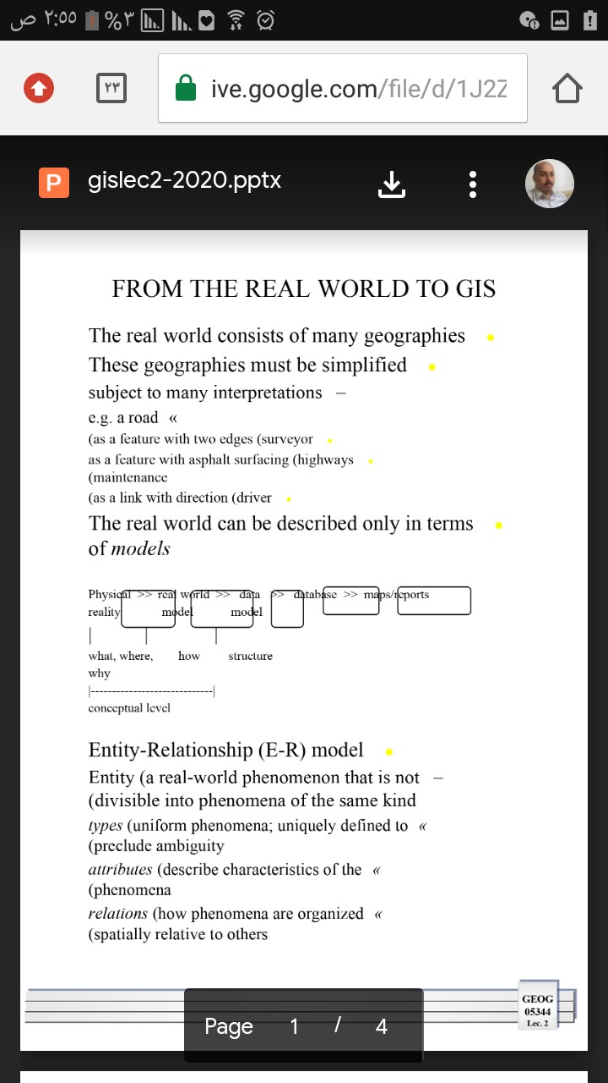

material PDF of course which student can get it and download it.

### Mufic Chat

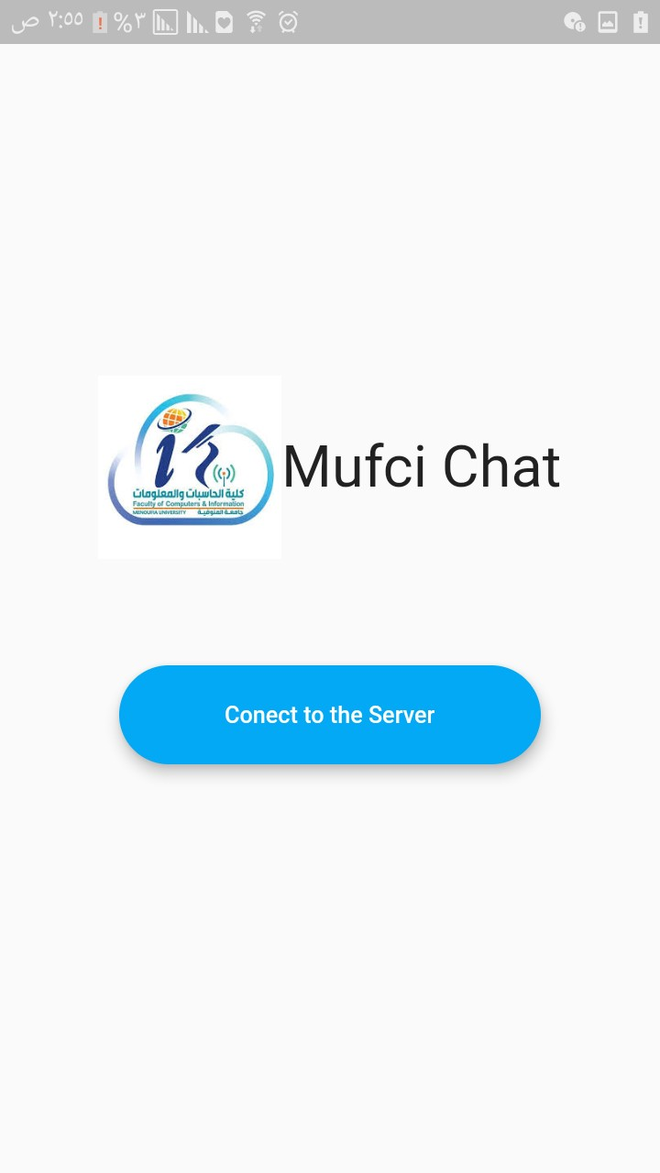

**chat room in it student can connect with each other and doctors**

### to get any FAQ .

1. **Chat room**

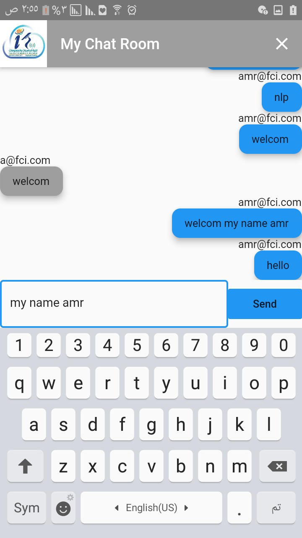

1. Chapter 1: Definitions 3
   1. Mobile Application 3
   2. Web Application 14
2. Chapter 2 : Introduction 28
   1. Title of project : credit hour system 28
   2. Project Description 28
   3. Motivation 29
   4. Languages to be used 29
   5. Future of our Project 30
3. Chapter 3: Modeling the Requirements 31
   1. Modules 31
   2. User Requirements 34
   3. System Requirement 40
   4. UML Diagrams 41
   5. class diagram 51
   6. Software architectural pattern 54
4. Chapter 4: Configuration Management 56
   1. Mobile Application(Android) 56
   2. Web Application 58
   3. Software Development 63
   4. Design Constrains 63
5. Chapter 5: Database 65
   1. Introduction 65
   2. ERD 66
6. Chapter 6: Testing 67
   1. Testing Methods 68
   2. Testing levels 74
7. Chapter 7: Screen shots of working Apps 80
   1. Web Application 80
   2. Mobile Application 107